REGULAR MEETING
OF THE
ELMWOOD PARK MAYOR AND COUNCIL
APRIL 16, 2020
7:00P.M.
- CALL TO ORDER:

- PRAYER & FLAG SALUTE:
- STATEMENT OF COMPLIANCE:
Whereas, Chapter 231 of the Public Laws of the State of New Jersey requires at the commencement of every meeting a Statement of Compliance be read by the presiding officer.

Now, Therefore Be Advised, that the meeting requirements for this meeting have been met by publishing a special meeting notice in The Record and Herald News and by posting such notice in the office of the Borough Clerk as well as in a public place within the Municipal Building, and by notifying interested citizens. Said notice was posted on January 8, 2020. An additional notice reflecting the time change was transmitted on April 14, 2020.
- APPROVAL OF MINUTES:
September 13, 2018 – Special Public Meeting
October 4, 2018 – Work Session Meeting
October 11, 2018 – Work Session Meeting
October 11, 2018 – Executive Session Meetings
December 6, 2018 – Work Session Meeting
December 6, 2018 – Executive Session Meeting
December 13, 2018 – Special Work Session Meeting
December 13, 2018 – Executive Session Meeting
April 2, 2020 – Special Public Meeting
April 2, 2020 – Work Session Meeting
April 2, 2020 – Executive Session Meeting
- ORDINANCES: FIRST READING
R-172-20 Introduce Ord. #20-11
AN ORDINANCE ESTABLISHING A “NO LEFT TURN” AT THE INTERSECTIONS OF PATERSON AVENUE AND RIVER DRIVE AND AMENDING CHAPTER VII OF THE CODE OF THE BOROUGH OF ELMWOOD PARK TITLED "TRAFFIC" MORE SPECIFICALLY SECTION 7-23 TITLED “TURN PROHIBITION”

R-173-20 Introduce Ord. #20-12
AN ORDINANCE AMENDING CHAPTER VII OF THE CODE OF THE BOROUGH OF ELMWOOD PARK TITLED "TRAFFIC" MORE SPECIFICALLY SECTION 7-10.2 TITLED “STOPPING OR STANDING PROHIBITED ON CERTAIN STREETS ON CERTAIN DAYS AT CERTAIN TIMES”

R-174-20 Introduce Ord. #20-13
AN ORDINANCE OF THE BOROUGH OF ELMWOOD PARK IN THE COUNTY OF BERGEN AND STATE OF NEW JERSEY AMENDING CHAPTER 11 entitled “housing”, MORE SPECIFICALLY ARTICLE 11-4 ENTITLED “illegal apartments” OF THE CODE OF THE BOROUGH, BY REVOKING SAID SECTION AND REPLACING SAME WITH THIS PROPOSED ORDINANCE
R-175-20 Introduce Ord. #20-14
AN ORDINANCE OF THE BOROUGH OF ELMWOOD PARK IN THE COUNTY OF BERGEN AND STATE OF NEW JERSEY AMENDING CHAPTER 4 entitled “Licensing and business regulation”, MORE SPECIFICALLY ARTICLE 4-39.2 ENTITLED “DEFINITIONS” AND ARTICLE 4-39.4 ENTITLED “applications for permit; fees, term; regulation” AND ARTICLE 4-39.5 ENTITLED “LOCATION, PLACEMENT AND CONDITIONS” OF THE CODE OF THE BOROUGH, BY AMENDING AND REPLACING CERTAIN LANGUAGE CONTAINED IN THOSE SECTIONS AND REPLACING SAME WITH THE PROPOSED LANGUAGE IN THIS PROPOSED ORDINANCE

R-176-20 Introduce Ord. #20-15

AN ORDINANCE OF THE BOROUGH OF ELMWOOD PARK COUNTY OF BERGEN, STATE OF NEW JERSEY, AMENDING AND SUPPLEMENTING THE CODE OF THE BOROUGH MORE SPECIFICALLY CHAPTER VII ENTITLED “TRAFFIC”

SECOND READING
R-177-20 Introduce Ord. #20-10
AN ORDINANCE OF THE BOROUGH OF ELMWOOD PARK, COUNTY OF BERGEN, STATE OF NEW JERSEY, AMENDING AND SUPPLEMENTING THE CODE OF THE BOROUGH CHAPTER XXII, ENTITLED “STREETS AND SIDEWALKS," MORE SPECIFICALLY SECTION 22-3 ENTITLED “CURBS AND SIDEWALKS” MORE SPECIFICALLY SUBSECTION 22-3.2 ENTITLED “MAINTENANCE AND REPAIRS” SO AS TO INCLUDE CERTAIN LANGUAGE CLARIFYING THE OBLIGATION AND RESPONSIBILITY SETFORTH THEREIN UNDER CERTAIN SPECIAL CIRCUMSTANCES
- CONSENT AGENDA:
R-178-20 Approval of Payroll
R-179-20 Approval of Bills List
R-180-20 Authorize Purchase of Equipment – Witmer Public Safety Group,
Inc. – Fire Department
R-181-20 Authorize Purchase of Police Surveillance – Goosetown
Communications
R-182-20 Authorize Purchase of Wheel Load Weighers – Loadometer
Corporation – Police Department
R-183-20 Authorize Change Order – Fire Department Mini Pumper
Absolute Fire Protection Co.
R-184-20 Authorize Release of Performance Cash and Surety Bonds
R-185-20 Authorize Current Estimate #3 & Final – Emergency Generator –
Recreation Building – Manor II Electric, Inc.
R-186-20 Authorize Payment for Crossing Guards
R-187-20 Authorize Monthly Payment for Cleaning Services – Recreation
Department – Open Works
R-188-20 Approve Sick/Vacation Buyback Request
R-189-20 Award of Bid – FY2018 NJDOT Municipal Aid Program – Mola
Boulevard – Your Way Construction, Inc.
R-190-20 Authorize Emergency Repair Services – Colonnelli Bros., Inc.
R-191-20 Authorize Emergency Purchase – Sewer Improvements – Pumping
Services, Inc.
R-192-20 Appoint Gym Supervisor – Gabriela Yilatopa – Recreation
Department
R-193-20 Authorize the Execution of IT Professional Consulting Contract
Intrep Solutions LLC.
R-194-20 Authorize Payment – Servpro
R-195-20 Authorize Additional Funding – Special Legal Counsel – Police Department – Apruzzese, McDermott, Mastro & Murphy, P.C.
R-196-20 Authorize Not to Exceed Amount – Special Legal Counsel – Apruzzese, McDermott, Mastro & Murphy, P.C.
R-197-20 Resolution Approving Elmwood Park Fire Department Stipend Program – 1st Quarter Compensation
R-198-20 Resolution to Refund Overpayment
R-199-20 Corrective Resolution to Purchase Radio Equipment Northeast Communications – Fire Department
R-200-20 Authorizing the Submission of a TWA Application to the State DEP – River Drive Development
R-201-20 Appointment to Board of Health
R-202-20 Approve Handicap Parking Space – Martha Avenue
R-203-20 Rescind Resolution R-155-20 – Resolution to Refund Overpayment
R-204-20 Resolution to Approve Consent Agenda

- APPLICATIONS:
Bingo – Our Lady of Mount Virgin – May 15, 2020 & October 16, 2020

- DEPARTMENTAL REPORTS:
Board of Health Meeting Minutes – February 10, 2020

- COUNCIL REPORTS:

- MAYOR’S REPORT:

- PUBLIC HEARING:

- ADJOURNMENT:

BOROUGH OF ELMWOOD PARK
BERGEN COUNTY, NEW JERSEY
RESOLUTION R-172-20
RESOLUTION BY:
SECONDED BY:
INTRODUCE ORDINANCE #20-11
FIRST READING
BE IT RESOLVED, that an ordinance entitled:
AN ORDINANCE ESTABLISHING A “NO LEFT TURN” AT THE INTERSECTIONS OF PATERSON AVENUE AND RIVER DRIVE AND AMENDING CHAPTER VII OF THE CODE OF THE BOROUGH OF ELMWOOD PARK TITLED "TRAFFIC" MORE SPECIFICALLY SECTION 7-23 TITLED “TURN PROHIBITION”
be passed and adopted on first reading; and
BE IT RESOLVED, that a final hearing on said ordinance will be heard in the Municipal Building on Thursday, May 21, 2020 at 7:30PM or as soon thereafter as same can be heard, at which time any persons interested in said ordinance can be heard;
BE IT FURTHER RESOLVED, that the Borough Clerk be, and she is hereby authorized to advertise in a legal newspaper a notice of introduction and final hearing as required by law.

APPROVED: April 16, 2020
__________________________
Robert Colletti, Mayor
ATTEST: _____________________
Erin Delaney, MPA, RMC
Borough Clerk
Record of Council Vote on Passage
 | AYE | NAY | Abstain | Absent |  | AYE | NAY | Abstain | Absent
Fasolo |  |  |  |  | Pellegrine
Golabek |  |  |  |  | Wechtler
Ingui |  |  |  |  | Balistrieri
This resolution was approved by the Mayor and Council of the Borough of Elmwood Park at a regular scheduled meeting held on the 16th day of April 2020. Signed and sealed before me.
_____________________ _____________________
Erin Delaney, MPA, RMC Dated
Borough Clerk

BOROUGH OF ELMWOOD PARK
BERGEN COUNTY, NEW JERSEY
ORDINANCE NO.: 20-11
-------------------------------------------
AN ORDINANCE ESTABLISHING A “NO LEFT TURN” AT THE INTERSECTIONS OF PATERSON AVENUE AND RIVER DRIVE
AND AMENDING CHAPTER VII OF THE CODE OF THE BOROUGH OF ELMWOOD PARK TITLED "TRAFFIC" MORE SPECIFICALLY SECTION 7-23 TITLED “TURN PROHIBITION”

WHEREAS, the governing body of the Borough of Elmwood Park, in the County of Bergen and State of New Jersey, has determined that hazardous conditions exist which require the adoption of traffic regulations prohibiting left-hand turns at certain designated intersections; and

WHEREAS, the governing body of the Borough of Elmwood Park finds it necessary to regulate traffic and has determined a need to regulate said traffic by prohibiting vehicles from making a left-hand turn from Paterson Avenue onto the southbound lane of River Drive, from 7:00 A.M. to 9:00 A.M and 4:00 P.M. to 6:00 P.M., Mondays through Fridays; and

WHEREAS, the governing body of the Borough of Elmwood Park believes that these traffic regulations are necessary in order to protect the health, safety and welfare of those individuals who reside in the area of these designated intersections, as well as the safety of the public at large.

NOW, THEREFORE, BE IT ORDAINED, by the Mayor and Council of the Borough of Elmwood Park, in the County of Bergen and State of New Jersey, as follows:

SECTION 1. That section VII entitled “Traffic” of the code of the Borough of Elmwood Park more specifically subsection 7-23 entitled “turn Prohibition” is hereby amended to include this adopted amendment prohibiting vehicles from making a left-hand turn from Paterson Avenue onto the southbound lane of River Drive, from 7:00 A.M. to 9:00 A.M. and 4:00 P.M. to 6:00 P.M., Mondays through Fridays; and

SECTION 2. The responsible department of the Borough of Elmwood Park shall be responsible and directed through the Borough Administrator to install the necessary signs at the above-mentioned intersection.

SECTION 3. Penalties for violation. Any person who violates the provision of this Ordinance shall, upon conviction thereof, be fined in accordance to the respective and appropriate fine sections of the Borough of Elmwood Park and or as set forth in the Laws of the State of New Jersey.

SECTION 4. Enforcement. The Police Chief and the Police Department of the Borough of Elmwood Park shall assist and enforce the provisions of this Ordinance.

SECTION 5. Repealer. All Ordinances of the Borough of Elmwood Park to the extent that same are not inconsistent with this Ordinance shall remain in full force and effect until modified or repealed pursuant to law. All Ordinances or parts of Ordinances inconsistent herewith are hereby repealed as to such inconsistencies.

SECTION 6: Invalid Provisions.: If any section, subsection, sentence, clause or phrase of this Ordinance is for any reason held to be unconstitutional or invalid, such decision shall not affect the remaining portions of this Ordinance.

SECTION 7: Effective Date.: This Ordinance shall take effect immediately upon final passage and publication thereof as provide by law.

ATTEST: _____________________ APPROVED: ____________________
Erin Delaney, MPA, RMC Robert Colletti, Mayor
Borough Clerk
Introduced:
Adopted:

BOROUGH OF ELMWOOD PARK
BERGEN COUNTY, NEW JERSEY
RESOLUTION R-173-20
RESOLUTION BY:
SECONDED BY:
INTRODUCE ORDINANCE #20-12
FIRST READING
BE IT RESOLVED, that an ordinance entitled:
AN ORDINANCE AMENDING CHAPTER VII OF THE CODE OF THE BOROUGH OF ELMWOOD PARK TITLED "TRAFFIC" MORE SPECIFICALLY SECTION 7-10.2 TITLED “STOPPING OR STANDING PROHIBITED ON CERTAIN STREETS ON CERTAIN DAYS AT CERTAIN TIMES”
be passed and adopted on first reading; and
BE IT RESOLVED, that a final hearing on said ordinance will be heard in the Municipal Building on Thursday, May 21, 2020 at 7:30PM or as soon thereafter as same can be heard, at which time any persons interested in said ordinance can be heard;
BE IT FURTHER RESOLVED, that the Borough Clerk be, and she is hereby authorized to advertise in a legal newspaper a notice of introduction and final hearing as required by law.

APPROVED: April 16, 2020
__________________________
Robert Colletti, Mayor
ATTEST: _____________________
Erin Delaney, MPA, RMC
Borough Clerk
Record of Council Vote on Passage
 | AYE | NAY | Abstain | Absent |  | AYE | NAY | Abstain | Absent
Fasolo |  |  |  |  | Pellegrine
Golabek |  |  |  |  | Wechtler
Ingui |  |  |  |  | Balistrieri
This resolution was approved by the Mayor and Council of the Borough of Elmwood Park at a regular scheduled meeting held on the 16th day of April 2020. Signed and sealed before me.
_____________________ _____________________
Erin Delaney, MPA, RMC Dated
Borough Clerk

BOROUGH OF ELMWOOD PARK
BERGEN COUNTY, NEW JERSEY
ORDINANCE NO.: 20-12
-------------------------------------------
AN ORDINANCE AMENDING CHAPTER VII OF THE CODE OF THE BOROUGH OF ELMWOOD PARK TITLED "TRAFFIC" MORE SPECIFICALLY SECTION 7-10.2 TITLED “STOPPING OR STANDING PROHIBITED ON CERTAIN STREETS ON CERTAIN DAYS AT CERTAIN TIMES”

WHEREAS, the Mayor and Council have become aware of the necessity to regulate the particular parking on Paterson Avenue for the safety concerns of traffic and residents, in order to protect the health, safety and welfare of the residents of the Borough of Elmwood Park.

BE IT ORDAINED, by the Mayor and Council of the Borough of Elmwood Park,
County of Bergen, and State of New Jersey and pursuant to the applicable laws of the state of New Jersey the Mayor and Council ordains as follows:

Be it further Ordained, by the Mayor and Council of the Borough of Elmwood Park as follows:

SECTION 1: that Chapter VII of the Code of the Borough of Elmwood Park titled "Traffic" more specifically section 7-10.2 titled “Stopping or Standing Prohibited on Certain Streets on Certain Days at Certain Times” is hereby amended so as to include thereto the no parking on the Northern side of Paterson Avenue for a two (2) hour limit between the time of 8:00 A.M. and 5:00 P.M. in the Borough of Elmwood Park.

SECTION 2: That by way of this Ordinance the Mayor and Council of the Borough of Elmwood Park do hereby designate and establish a no parking on the Northern side of Paterson Avenue for a two (2) hour limit between the time of 8:00 A.M. and 5:00 P.M. in the Borough of Elmwood Park.

SECTION 3: The designated no parking with the two (2) hour limit between the time of 8:00 A.M. and 5:00 P.M. is in the interest of the public and its health, safety and welfare and the inhabitants and residents in said area.

SECTION 5: The responsible department of the Borough of Elmwood Park shall be responsible and directed through the Borough Administrator to install the necessary signs along the Northern side of Paterson Avenue.

SECTION 6: Penalties for violation. Any person who violates the provision of this Ordinance shall, upon conviction thereof, be fined in accordance to the respective and appropriate fine sections of the Borough of Elmwood Park and or as set forth in the Laws of the State of New Jersey.

SECTION 7: The Police Chief and the Police Department of the Borough of Elmwood Park, shall assist and enforce the provisions of this Ordinance.

SECTION 8: Repealer. All Ordinances of the Borough of Elmwood Park to the extent that same are not inconsistent with this Ordinance shall remain in full force and effect until modified or repealed pursuant to law. All Ordinances or parts of Ordinances inconsistent herewith are hereby repealed as to such inconsistencies.

SECTION 9: Invalid Provisions.: If any section, subsection, sentence, clause or phrase of this Ordinance is for any reason held to be unconstitutional or invalid, such decision shall not affect the remaining portions of this Ordinance.

SECTION 10: Effective Date.: This Ordinance shall take effect immediately upon final passage and publication thereof as provide by law.

ATTEST: _____________________ APPROVED: ____________________
Erin Delaney, MPA, RMC Robert Colletti, Mayor
Borough Clerk
Introduced:
Adopted:

BOROUGH OF ELMWOOD PARK
BERGEN COUNTY, NEW JERSEY
RESOLUTION R-174-20
RESOLUTION BY:
SECONDED BY:
INTRODUCE ORDINANCE #20-13
FIRST READING
BE IT RESOLVED, that an ordinance entitled:
AN ORDINANCE OF THE BOROUGH OF ELMWOOD PARK IN THE COUNTY OF BERGEN AND STATE OF NEW JERSEY AMENDING CHAPTER 11 entitled “housing”, MORE SPECIFICALLY ARTICLE 11-4 ENTITLED “illegal apartments” OF THE CODE OF THE BOROUGH, BY REVOKING SAID SECTION AND REPLACING SAME WITH THIS PROPOSED ORDINANCE
be passed and adopted on first reading; and
BE IT RESOLVED, that a final hearing on said ordinance will be heard in the Municipal Building on Thursday, May 21, 2020 at 7:30PM or as soon thereafter as same can be heard, at which time any persons interested in said ordinance can be heard;
BE IT FURTHER RESOLVED, that the Borough Clerk be, and she is hereby authorized to advertise in a legal newspaper a notice of introduction and final hearing as required by law.

APPROVED: April 16, 2020
__________________________
Robert Colletti, Mayor
ATTEST: _____________________
Erin Delaney, MPA, RMC
Borough Clerk
Record of Council Vote on Passage
 | AYE | NAY | Abstain | Absent |  | AYE | NAY | Abstain | Absent
Fasolo |  |  |  |  | Pellegrine
Golabek |  |  |  |  | Wechtler
Ingui |  |  |  |  | Balistrieri
This resolution was approved by the Mayor and Council of the Borough of Elmwood Park at a regular scheduled meeting held on the 16th day of April 2020. Signed and sealed before me.
_____________________ _____________________
Erin Delaney, MPA, RMC Dated
Borough Clerk

BOROUGH OF ELMWOOD PARK
BERGEN COUNTY, NEW JERSEY
ORDINANCE NO.: 20-13
-------------------------------------------
AN ORDINANCE OF THE BOROUGH OF ELMWOOD PARK IN THE COUNTY OF BERGEN AND STATE OF NEW JERSEY AMENDING CHAPTER 11 entitled “housing”, MORE SPECIFICALLY ARTICLE 11-4 ENTITLED “illegal apartments” OF THE CODE OF THE BOROUGH, BY REVOKING SAID SECTION AND REPLACING SAME WITH THIS PROPOSED ORDINANCE

Purpose
The purpose of this chapter is to establish a uniform policy for treatment of property owners, and their agents, who allow unlawful occupancy of dwelling units and tenants who must relocate by reason of the actions of the property owner, and their agents, and provide for the protection of the health, safety and welfare of the residents of the Borough of Elmwood Park.

WHEREAS, Pursuant to the provisions as set forth under the laws of the State of New Jersey (N.J.S.A. 40:49-5.1), which sets forth the right of a municipality to set up standards and regulations in determining whether dwellings in the respective municipality are safe, sanitary and fit for human habitation and rental; and

WHEREAS, this ordinance is to provide a means to address the overcrowding of the off-street parking conditions for the residents and citizens of our community, and to protect the public by regulate to a limited degree the density of population; and to promote the health, safety and welfare of the citizens and residents of the Borough of Elmwood Park; and

WHEREAS, the Borough Council of the Borough of Elmwood Park, County of Bergen, State of New Jersey has reviewed, considered and has determined that there is a need for the overall safety, health and welfare of the citizens and residents of the Borough to amend the section 11-4 of the Borough Code entitled “ILLEGAL APARTMENTS” so as to prevent overburdening the off-street parking situation and controlling overcrowding and the density of structures and buildings which has a detrimental effect on the Borough as a whole; and

WHEREAS, upon the advice and recommendation of the Borough’s building department and Borough Planner as well as the Borough Engineer, the Borough Council of the Borough of Elmwood Park find that it is necessary to update the existing section 11-4 of the Code in order to bring same up to present standards so as to assist the Borough in alleviating the current off-street parking situation, controlling overcrowding and the density of its population.

NOW, THEREFORE, BE IT ORDAINED by the Borough Council of the Borough of Elmwood Park in the County of Bergen and State of New Jersey that Section 11-4 entitled “Illegal Apartments”, of Chapter 11 entitled “Housing”, be and is hereby repealed and revoked in total and shall be amended and replaced with the following:

Section 11-4 UNLAWFUL DWELLINGS

SectIon 11-4.1 PURPOSE.
The purpose of this chapter is to establish a uniform policy for treatment of property owners, and their agents, who allow unlawful occupancy of dwelling units and tenants who must relocate by reason of the actions of the property owner, and their agents, and provide for the protection of the health, safety and welfare of the residents of the Borough of Elmwood Park.

Section 11-4.2 Definitions.
As used in this section, the following terms shall have the following meanings:

DWELLING UNIT — A building or portion thereof containing cooking and plumbing facilities for one family, including rooms used more or less for transient occupancy.

FAMILY — One or more persons related by blood or marriage, or a group
of not more than four persons, not necessarily related by marriage or blood, living together as a single housekeeping unit.
REAL ESTATE PROPERTY OWNER — All-natural persons, partnerships, joint ventures and corporations as shown on the official tax records of the Borough of Elmwood Park.

RELOCATION COSTS — The actual and reasonable expense of moving a person and/or personal property.

UNLAWFUL DWELLING — A dwelling unit for which no valid certificate of occupancy has been issued by the Borough of Elmwood Park Building Department and Fire Prevention Bureau.
ATTIC- Any space above the top floor of a dwelling unit.

BASEMENT- Any space below the habitable space located on the first floor of a dwelling unit.

DWELLING- Any room or group of rooms located within a building forming a single habitable unit with facilities which are used, designed or arranged to be used for living, sleeping, cooking and sanitary facilities.

KITCHEN- Any room which may contain a sink, refrigerator, kitchen counter and cabinets and a cooking device, or any other combination of the above, which includes stoves, ovens, microwaves, convection ovens, electric grills, hot plates or any other device in which or on which food can be cooked.

REALESTATE PROPERTY OWNER- All natural persons, partnerships, joint ventures and corporations as shown on the official tax records of the Borough of Elmwood Park.

enforcement officer- The Construction Official, Fire Official, or their designee of the Borough of Elmwood Park are hereby designated as the officers to exercise the powers prescribed by this chapter.

Section 11-4.3 PROHIBITED.
(A) No real estate property owner, its agents and or employees, shall permit or allow any person or family to occupy an unlawful dwelling unit.

Section 11-4.4 Restrictions.

A. CONSTRUCTION AND USE PROHIBITION.
1. It shall be prohibited to construct or have a kitchen or kitchen facilities, sink or bathroom in the attic.

2. Attic spaces may not be used for sleeping areas unless they are approved by the Zoning Board of Adjustment and/or Planning Board and meet all requirements of the Uniform Construction Code. Any approved attic bedroom must be connected directly with the apartment below, without passing through a common hallway.

3. Basements shall not contain a kitchen and a bathroom except as follows:
(a) If a kitchen unit is installed, then only a partial bathroom with a sink shall be allowed with no shower or tub.
(b) If a bathroom is installed with a sink, toilet and shower, then no kitchen facilities will be allowed in a basement area.

4. Renovation of basements.
(a) All renovations of basements shall be restricted to one large habitable area, with no other habitable rooms. Storage rooms may be erected, provided that they remain unfinished without locking doors.

5. Bedrooms.
(a) No bedrooms shall be permitted in basements or areas below the first-floor habitable area.

6. Basement areas.
(a) All basement areas shall be attached directly to the dwelling unit above without passing through a common hallway, nor shall there be locking doors between the basement and the habitable area and the dwelling unit above.
(b) All exterior basement access shall be permissible by utilizing a hatch style door. No vestibule basement entries shall be permitted.

7. Livable floor space requirements.
(a) No more than one person over four years of age for each 125 square feet of floor space therein usable for living purposes shall live, sleep or otherwise occupy any dwelling unit.

8. Bedroom occupancy.
(a) No bedroom shall be utilized for sleeping purposes by more than two adult occupants. Every bedroom occupied or utilized for sleeping purposes shall be deemed to be a bedroom for the purposes of this Code section notwithstanding the fact that said room may be utilized for other purposes. Every said room occupied for sleeping purposes by one occupant shall be at least 70 square feet of floor space, and every room occupied for sleeping purposes by more than one occupant shall be at least 50 square feet for each occupant thereof.

Section 11-4.5 Exceptions; preexisting and approved dwellings.
A. All previously approved basement and attic units which were approved prior to the adoption of this section shall be allowed to continue in use and shall be considered preexisting, nonconforming areas; Provided, however, that this approval shall only be permitted if:

(1) All building and construction permits were obtained and complied with at the time of construction; and

(2) The Building Department records, and tax assessment records confirm existence of this area.

Section 11-4.6 ENFORCEMENT.
(A) Designation of enforcement officer. The Construction Official, Fire Official, or their designee of the Borough of Elmwood Park are hereby designated as the officers to exercise the powers prescribed by this chapter.

Section 11-4.7 Order to abate and remove.
(A) In no event shall a certificate of occupancy or continued certificate of occupancy or conditional certificate of occupancy be issued upon the transfer of title of any property if there are any violations of the above sections.

(B) In order to secure a certificate of occupancy or continued certificate of occupancy or conditional certificate of occupancy in order to effectuate a transfer of title in accordance with the provisions of the Code of the Borough of Elmwood Park, all work which was installed or performed without the required permits and approvals must be removed to the satisfaction of the Construction Official.

Section 11-4.8 Inspections; right of entry.
(A) The Construction Official or Fire Official is hereby authorized and directed to make inspections to determine the condition of dwellings, dwelling units, rooming units and premises located within the Borough of Elmwood Park in order that he or she may perform his or her duty of safeguarding the health, safety and welfare of the occupants of dwellings and of the general public.

(B) For the purpose of making such inspections the Construction Official or Fire Official is hereby authorized to enter, examine and survey at all reasonable times all dwellings, dwelling units, rooming units and premises when such consent for inspection has been granted by the property owner, its agent or employee and /or by the occupant of said premises.

(C) Should the property owner, its agent or employee or occupant denies the Construction Official or Fire Official access or entry to any dwelling, dwelling unit, rooming unit or premises located within the Borough of Elmwood Park, the Construction Official or Fire Official or his or her authorized representative shall obtain a proper warrant or other remedy provided by law to secure such entry.

Section 11-4.9 issuing of a proper warrant.
(A) Upon the issuing of a proper warrant, the property owner, it’s agent and /or employee or occupant of every dwelling, dwelling unit and rooming unit, or the person in charge thereof, shall give the Construction Official or Fire Official full access to such dwelling, dwelling unit or rooming unit and its premises at all reasonable times for the purpose of such inspection, examination and survey.

(B) Every occupant of a dwelling or dwelling unit shall give the owner thereof or his agent or employee access to any part of such dwelling or dwelling unit or its premises at all reasonable times, subject to due process and the laws of the State of New Jersey, for the purpose of making such repairs or alterations as are necessary to effect compliance with the provisions of this chapter or with any lawful rule or regulation adopted or any lawful order issued pursuant to the provisions of this chapter.

Section 11-4.10 Adoption of rules and regulations.
(A) The Construction Official or Fire Official is hereby authorized and empowered to make and adopt such written rules and regulations as he or she may deem necessary for the proper enforcement of the provisions of this chapter, provided, however, that such rules and regulations shall not be in conflict with the provisions of this chapter nor in anyways alter, amend or supersede any of the provisions thereof. The Construction Official or Fire Official shall file a certified copy of all rules and regulations which he or she may adopt in his or her office and in the office of the Clerk of the Borough of Elmwood Park.

Section 11-4.11 Conformity with standards.
(A) No person shall occupy as owner occupant or rent to another for occupancy any dwelling or dwelling unit for the purpose of living therein which does not conform to the provisions of the New Jersey State Housing Code, established hereby as the standard to be used in determining whether a dwelling is safe, sanitary and fit for human habitation.

Section 11-4.12 Tenants entitled to assistance; amount.
(A) Any tenant who receives a notice of eviction that results from zoning or code enforcement activity for an illegal occupancy, shall be considered a displaced person and shall be entitled to relocation assistance in the amount equal to two month’s rent paid to the displaced person. The owner-landlord of the structure shall be liable for the payment of relocation assistance pursuant to this section.

Section 11-4.13 Violations and penalties.
(A) Enforcement.
1. In the event that the Construction Official, Fire Official, Housing Official, Police Department, Health Department, Property Maintenance Officials, Fire Department or any other municipal enforcing agency has upon observation determined that in its opinion a violation of any section of the state building, fire, criminal or municipal ordinances has occurred, the parties are directed to issue a summons to the offending party.

2. The investigative agencies, as noted in Subsection 1(a), shall be directed to advise the offending party that each day the summons violation exist shall be deemed and constitute a separate offense, and that the effective enforcing official shall be directed to issue daily summonses from the date that the violation is discovered or determined through the date of court appearance.

Section 11-4.14 Penalty for Violation.
(A) Upon determination that a violation exists.
1. Where upon there is a determination that the court finds, upon such findings and determination the Court shall impose one or more of the following for each and every violation hereof:

(a). A minimum fine of $1,500; and /or

(b). Imprisonment for a term not exceeding 90 days; and/or

(c). A period of community service not exceeding 90 days. Each day in which the owner violates a provision of this chapter shall be deemed as a separate offense.

Section 11-4.15 Requiring Reimbursement.
(A) In addition to the penalty provisions setforth above in S(1)(a) from the owner-landlord of the structure, the owner-landlord shall be responsible for relocation assistance to be paid to a displaced tenant, as its setforth in section Q(1) of this chapter, in addition thereto, the owner-landlord may be fined for zoning, housing code, or fire code violation for an illegal occupancy.

BE IT FURTHER ORDAINED, that if for any reason, any section or provision of this Ordinance shall be held to be unconstitutional or invalid by any Court, the same shall not affect any other section or provision of this Ordinance, except so far as the section or provision so declared unconstitutional or invalid shall be severed from the remainder or any portion thereof.

SECTION 3. All ordinances or parts thereof, which are inconsistent with the provisions of this Ordinance, are hereby repealed to the extent of their inconsistencies.

BE IT FURTHER ORDAINED, This Ordinance shall take effect immediately upon its final passage and publication as required and in accordance with the law.

ATTEST: _____________________ APPROVED: ____________________
Erin Delaney, MPA, RMC Robert Colletti, Mayor
Borough Clerk
Introduced:
Adopted:

BOROUGH OF ELMWOOD PARK
BERGEN COUNTY, NEW JERSEY
RESOLUTION R-175-20
RESOLUTION BY:
SECONDED BY:
INTRODUCE ORDINANCE #20-14
FIRST READING
BE IT RESOLVED, that an ordinance entitled:
AN ORDINANCE OF THE BOROUGH OF ELMWOOD PARK IN THE COUNTY OF BERGEN AND STATE OF NEW JERSEY AMENDING CHAPTER 4 entitled “Licensing and business regulation”, MORE SPECIFICALLY ARTICLE 4-39.2 ENTITLED “DEFINITIONS” AND ARTICLE 4-39.4 ENTITLED “applications for permit; fees, term; regulation” AND ARTICLE 4-39.5 ENTITLED “LOCATION, PLACEMENT AND CONDITIONS” OF THE CODE OF THE BOROUGH, BY AMENDING AND REPLACING CERTAIN LANGUAGE CONTAINED IN THOSE SECTIONS AND REPLACING SAME WITH THE PROPOSED LANGUAGE IN THIS PROPOSED ORDINANCE
be passed and adopted on first reading; and
BE IT RESOLVED, that a final hearing on said ordinance will be heard in the Municipal Building on Thursday, May 21, 2020 at 7:30PM or as soon thereafter as same can be heard, at which time any persons interested in said ordinance can be heard;
BE IT FURTHER RESOLVED, that the Borough Clerk be, and she is hereby authorized to advertise in a legal newspaper a notice of introduction and final hearing as required by law.

APPROVED: April 16, 2020
__________________________
Robert Colletti, Mayor
ATTEST: _____________________
Erin Delaney, MPA, RMC
Borough Clerk
Record of Council Vote on Passage
 | AYE | NAY | Abstain | Absent |  | AYE | NAY | Abstain | Absent
Fasolo |  |  |  |  | Pellegrine
Golabek |  |  |  |  | Wechtler
Ingui |  |  |  |  | Balistrieri
This resolution was approved by the Mayor and Council of the Borough of Elmwood Park at a regular scheduled meeting held on the 16th day of April 2020. Signed and sealed before me.
_____________________ _____________________
Erin Delaney, MPA, RMC Dated
Borough Clerk

BOROUGH OF ELMWOOD PARK
BERGEN COUNTY, NEW JERSEY
ORDINANCE NO.: 20-14
-------------------------------------------
AN ORDINANCE OF THE BOROUGH OF ELMWOOD PARK IN THE COUNTY OF BERGEN AND STATE OF NEW JERSEY AMENDING CHAPTER 4 entitled “Licensing and business regulation”, MORE SPECIFICALLY ARTICLE 4-39.2 ENTITLED “DEFINITIONS” AND ARTICLE 4-39.4 ENTITLED “applications for permit; fees, term; regulation” AND ARTICLE 4-39.5 ENTITLED “LOCATION, PLACEMENT AND CONDITIONS” OF THE CODE OF THE BOROUGH, BY AMENDING AND REPLACING CERTAIN LANGUAGE CONTAINED IN THOSE SECTIONS AND REPLACING SAME WITH THE PROPOSED LANGUAGE IN THIS PROPOSED ORDINANCE

WHEREAS, Pursuant to the provisions as set forth under the laws of the State of New Jersey which grants the right to a municipality to set up standards and regulations relating to the health, safety and welfare of its residents and maintain proper and safe sanitary conditions within the municipality; and

WHEREAS, the Borough Council of the Borough of Elmwood Park, County of Bergen, State of New Jersey has reviewed, considered and has determined that there is a need to amend section 4-39.2 and 4-39.4 and 4-39.5 for the overall safety, health and welfare of the citizens and residents of the Borough; and

WHEREAS, upon the advice and recommendation of the Borough’s building department and Borough Business Administrator and Borough Chief of Police, the Borough Council of the Borough of Elmwood Park find that it is necessary to update 4-39.2 and 4-39.4 and 4-39.5 of the Code in order to bring same up to present standards so as to assist the Borough in alleviating potential health and safety condition.

NOW, THEREFORE, BE IT ORDAINED by the Borough Council of the Borough of Elmwood Park in the County of Bergen and State of New Jersey that Section 4-39.2 and 4-39.4 and 4-39.5 entitled “Definitions” and “Application for Permit; Fees, Term; Regulation”, and “Location, Placement and Condition”, respectively be and are hereby amended and replaced with the following Bolded and underlined language and replace the language enclosed in Brackets and underlined, as well as incorporate the added language which is bolded and underlined:

Section 4-39.2 Definitions.
As used in this section, the following terms shall have the following meanings indicated:

DUMPSTER
Shall mean a container or debris-transfer body commonly used for the placing or collection of debris and building materials during construction or renovation.

ENFORCEMENT AGENCY
Shall mean the [Department of Police] Police Department and Building Department of the Borough of Elmwood Park.

LICENSING OFFICE
Shall mean the Police Department or the Building Department of the Borough of Elmwood Park.

PERSON
Shall mean and include any person, firm, partnership, association, corporation, company, organization or entity of any type.

PUBLIC AREA
Shall mean and include any street, sidewalk, highway, public lane, alley, Borough parking lot or other public place in the Borough.

RESIDENTIAL ZONE
Shall mean any residential zone, as defined in Chapter 34, Land Use and Development, of the Borough of Elmwood Park Code.

Section 4-39.4 Application for Permit; Fees, Term; Regulations.

a. Any person seeking to place, permit to be placed or utilize a dumpster in a public area in the Borough of Elmwood Park shall do so only after having obtained a permit from the [Police Department] Building Department of the Borough of Elmwood Park. In order to obtain a permit, an application for a permit on a form to be furnished by the [Department of Police] Building Department of the Borough of Elmwood Park shall be filed, and the appropriate fee shall be paid.

b. The application shall require that the applicant specify the exact proposed location of the dumpster, the size and capacity thereof, the length of time that said use is required and the contemplated use of the dumpster.

c. The fee for obtaining a permit to place a dumpster in a public area shall be $50. The permit shall be issued for a term not to exceed [15] 7 days and may be renewed once upon the written request of the applicant without the filing of a new application but upon payment of an additional fee, renewal fee in the amount of $50.

d. No dumpster in excess of 30 yards shall be permitted in the public area of the Borough of Elmwood Park. The permit shall be issued for a specific period of time based on the estimate of the applicant at the time the application is filed.

e. At the time the application is filed, each applicant shall furnish the Borough of Elmwood Park with a certificate of insurance containing limits of at least $100,000/$300,000 for bodily injury and one $100,000 for property damage, which shall name the Borough of Elmwood Park as an additional insured and which shall be noncancelable during the permit period.

f. Each applicant for a permit to place a dumpster in a public area shall furnish the Borough of Elmwood Park with sufficient surety to be determined by the Borough Engineer to guaranty against damage to the streets, curbs and sidewalks or other improvements in the public right-of-way.

g. No dumpster shall be placed in a public area more than 24 hours prior to commencement of construction and shall not remain therein more than 24 hours subsequent to construction being completed.

h. No permit shall be issued if the [Department of Police] Police Department and Building Department determines that issuance of a permit will constitute a danger to public safety or an unwarranted interference with the efficient movement of traffic.

i. A permit may be revoked at any time during its term if the [Department of Police] Police Department and Building Department of the Borough of Elmwood Park determines that the placement or use of a dumpster constitutes a hazard to the health, safety or welfare of the citizens of the Borough of Elmwood Park or for any other reason constitutes a nuisance.

j. The Mayor and Council of the Borough of Elmwood Park may exempt from all but the safety requirement of this chapter any persons contracting with the Borough.

Section 4-39.5 Location, Placement and Condition.

a. No dumpster shall be placed in a public area in a residential zone unless it is determined by the [Department of Police] Building Department that there is not sufficient room on the private property of the person utilizing the dumpster to place the dumpster and therefore, the dumpster is required to be placed in a public area. No dumpster placed on private property, otherwise unregulated by this section, shall impede the flow of pedestrian or vehicular traffic or safety site lines.

b. Dumpsters may be placed in public areas only upon the determination of the [Department of Police] Building Department that there is no safe or practical place where the dumpster may be paced other than in the public area.

c. All dumpsters placed in public area are required to comply with the following conditions:
1. Planking or wood sheeting of sufficient size is required to be placed under the wheels or road contact area to protect the roadway from damage. If the dumpster has wheels, they must be chucked to prevent movement.
2. Flashing, warning, amber, barricade-mounted lights are required to be placed in the dumpster to provide a visual warning to those utilizing the roadway or public right-of-way. The lights are required to be operable at all times.
3. No dumpster shall be permitted in a public area where the placement of which interferes with the free and safe flow of traffic or which otherwise stands in a hazardous location.
4. Dumpsters shall not be permitted to be placed in a public area on certain designated holidays, sale days and special event days that occur from time to time during the year.

d. Upon removal of the dumpster, the public area shall be swept clean of all loose debris and restored to its former condition in accord with the standards of the Borough of Elmwood Park Engineer.

e. All dumpsters shall at all times be kept in good repair and shall be structurally sound and leak-proof and shall be painted as to prevent rust or deterioration and shall be constructed to stand firmly upright.

f. All dumpsters placed on private property shall be required to comply with the following conditions:

1. No dumpster shall be kept for longer than a 30-day period.
2. No dumpster shall be kept for more than 3 days after it has been filled to capacity.
3. No dumpster shall create a nuisance for the duration of time that it is located on the property.

Section 4-39.6 Penalties.

Each day that a dumpster is placed or utilized in violation of the terms of this section shall constitute a separate offense. Each offense hereunder shall be punishable by a minimum of $50.

BE IT FURTHER ORDAINED, that if for any reason, any section or provision of this Ordinance shall be held to be unconstitutional or invalid by any Court, the same shall not affect any other section or provision of this Ordinance, except so far as the section or provision so declared unconstitutional or invalid shall be severed from the remainder or any portion thereof.

BE IT FURTHER ORDAINED, all ordinances or parts thereof, which are inconsistent with the provisions of this Ordinance, are hereby repealed to the extent of their inconsistencies.

BE IT FURTHER ORDAINED, this Ordinance shall take effect immediately upon its final passage and publication as required and in accordance with the law.
ATTEST: _____________________ APPROVED: ____________________
Erin Delaney, MPA, RMC Robert Colletti, Mayor
Borough Clerk
Introduced:
Adopted:

BOROUGH OF ELMWOOD PARK
BERGEN COUNTY, NEW JERSEY
RESOLUTION R-176-20
RESOLUTION BY:
SECONDED BY:
INTRODUCE ORDINANCE #20-15
FIRST READING
BE IT RESOLVED, that an ordinance entitled:
AN ORDINANCE OF THE BOROUGH OF ELMWOOD PARK COUNTY OF BERGEN, STATE OF NEW JERSEY, AMENDING AND SUPPLEMENTING THE CODE OF THE BOROUGH MORE SPECIFICALLY CHAPTER VII ENTITLED “TRAFFIC”
be passed and adopted on first reading; and
BE IT RESOLVED, that a final hearing on said ordinance will be heard in the Municipal Building on Thursday, May 21, 2020 at 7:30PM or as soon thereafter as same can be heard, at which time any persons interested in said ordinance can be heard;
BE IT FURTHER RESOLVED, that the Borough Clerk be, and she is hereby authorized to advertise in a legal newspaper a notice of introduction and final hearing as required by law.

APPROVED: April 16, 2020
__________________________
Robert Colletti, Mayor
ATTEST: _____________________
Erin Delaney, MPA, RMC
Borough Clerk
Record of Council Vote on Passage
 | AYE | NAY | Abstain | Absent |  | AYE | NAY | Abstain | Absent
Fasolo |  |  |  |  | Pellegrine
Golabek |  |  |  |  | Wechtler
Ingui |  |  |  |  | Balistrieri
This resolution was approved by the Mayor and Council of the Borough of Elmwood Park at a regular scheduled meeting held on the 16th day of April 2020. Signed and sealed before me.
_____________________ _____________________
Erin Delaney, MPA, RMC Dated
Borough Clerk

BOROUGH OF ELMWOOD PARK
BERGEN COUNTY, NEW JERSEY
ORDINANCE NO.: 20-15
-------------------------------------------
AN ORDINANCE OF THE BOROUGH OF ELMWOOD PARK COUNTY OF BERGEN, STATE OF NEW JERSEY, AMENDING AND SUPPLEMENTING THE CODE OF THE BOROUGH MORE SPECIFICALLY CHAPTER VII ENTITLED “TRAFFIC”

SECTION 7-8.1 REGULATION NOT EXCLUSIVE.
WHEREAS, the governing body of the Borough of Elmwood Park in the County of Bergen and State of New Jersey, has determined that there exist the need to create more availability off street parking spaces which would require the need to adoption traffic regulations regarding parking within a stop sign; and

WHEREAS, the Mayor and Council has determined that there is a necessity to regulate the distance that vehicles would be allowed to park within a designated stop sign; and

WHEREAS, the Mayor and Council is aware that the restriction for parking within a stop sign is controlled and regulated by State Statute N.J.S.A. 39:4-138(h) which requires a 50-foot distance from such stop sign; and

WHEREAS, the Mayor and Council is also aware, that the State Statute N.J.S.A. 39:4-138.6 allows a municipality to mandate by ordinance the permissible distance a motor vehicle may park from a crosswalk, side line of a street or intersecting highway, or "stop" sign; and
WHAREAS, the Mayor and Council are aware that the State Statute N.J.S.A. 39:4-138.6
Restricts a municipality from permit parking within 25 feet of a crosswalk or side line of a street or intersecting highway or within 50 feet of a "stop" sign in a school zone during hours when school is in session; and

WHEREAS, the Mayor and Council of the Borough of Elmwood Park believes that this amendment to the traffic regulations is necessary in order to protect the health, safety and welfare of those individuals who reside in the area of these designated intersections, as well as the safety of the public at large.

NOW, THEREFORE, BE IT ORDAINED, by the Borough of Elmwood Park in the County of Bergen and State of New Jersey, that Chapter VII, “Traffic”, of the General Ordinances of the Borough of Elmwood Park, New Jersey more specifically subsection 7-8.1 is hereby amended and supplemented to include the following language:

“That notwithstanding N.J.S.A. 39:4-138(h) which requires a 50-foot distance for parking within a stop sign, that distance is hereby diminished to 20-foot distance for parking within a stop sign in the Borough. However, such lessening of distance shall not apply to any stop sign located in a school zone, while and during school hours and schools are in session. Under such circumstance the distance for parking within a stop sign in such school areas shall be 50-feet as set forth in state statute N.J.S.A. 39:4-138(h) when such school located in such area is in session or during school hours”

BE IT FURTHER ORDAINED as follows:

SECTION 1. That this Ordinance shall take effect immediately upon final passage and publication in accordance with the law, but not before receipt of any approvals required by the New Jersey Department of Transportation and/or the County of Bergen.

SECTION 2. That, upon the effective date of this Ordinance, the appropriate Borough officials and/or employees shall be authorized to post applicable signs and or curb marking or painting in the affected areas throughout the Borough.

SECTION 3. That, upon the effective date of this Ordinance, it shall be illegal for the motoring public to park within a designated stop sign less than 20-feet as referenced above, and the Borough of Elmwood Park Police Department shall be authorized to enforce the said traffic regulations as though it was a violation of Section 7-37.6, of the General Ordinances of the Borough of Elmwood Park, New Jersey.

SECTION 4. In the event any section, part or provision of this Ordinance shall be held unconstitutional or invalid by any Court, such holding shall not affect the validity of this Ordinance or any remaining part of this Ordinance other than the part held unconstitutional or invalid.

SECTION 5. All ordinances or parts thereof, which are inconsistent with the provisions of this Ordinance, are hereby repealed to the extent of their inconsistencies.

SECTION 6. This Ordinance shall take effect immediately upon its final passage and publication as required by law.

ATTEST: _____________________ APPROVED: ____________________
Erin Delaney, MPA, RMC Robert Colletti, Mayor
Borough Clerk
Introduced:
Adopted:

BOROUGH OF ELMWOOD PARK
BERGEN COUNTY, NEW JERSEY
RESOLUTION R-177-20
RESOLUTION BY:
SECONDED BY:
INTRODUCE ORDINANCE #20-10
SECOND READING
WHEREAS, a public notice has been given by the Borough Clerk that an ordinance entitled:
AN ORDINANCE OF THE BOROUGH OF ELMWOOD PARK, COUNTY OF BERGEN, STATE OF NEW JERSEY, AMENDING AND SUPPLEMENTING THE CODE OF THE BOROUGH CHAPTER XXII, ENTITLED “STREETS AND SIDEWALKS," MORE SPECIFICALLY SECTION 22-3 ENTITLED “CURBS AND SIDEWALKS” MORE SPECIFICALLY SUBSECTION 22-3.2 ENTITLED “MAINTENANCE AND REPAIRS” SO AS TO INCLUDE CERTAIN LANGUAGE CLARIFYING THE OBLIGATION AND RESPONSIBILITY SETFORTH THEREIN UNDER CERTAIN SPECIAL CIRCUMSTANCES

WHEREAS, said ordinance was introduced and passed at a meeting held on Thursday, March 19, 2020 and that further consideration of this ordinance would be taken up at this meeting; and
WHEREAS, all persons interested in said ordinance were given an opportunity to be heard concerning the same;
NOW THEREFORE BE IT RESOLVED, by the Mayor and Council of the Borough of Elmwood Park, that an ordinance entitled:
AN ORDINANCE OF THE BOROUGH OF ELMWOOD PARK, COUNTY OF BERGEN, STATE OF NEW JERSEY, AMENDING AND SUPPLEMENTING THE CODE OF THE BOROUGH CHAPTER XXII, ENTITLED “STREETS AND SIDEWALKS," MORE SPECIFICALLY SECTION 22-3 ENTITLED “CURBS AND SIDEWALKS” MORE SPECIFICALLY SUBSECTION 22-3.2 ENTITLED “MAINTENANCE AND REPAIRS” SO AS TO INCLUDE CERTAIN LANGUAGE CLARIFYING THE OBLIGATION AND RESPONSIBILITY SETFORTH THEREIN UNDER CERTAIN SPECIAL CIRCUMSTANCES
pass on final reading.
APPROVED: April 16, 2020
__________________________
Robert Colletti, Mayor
ATTEST: _____________________
Erin Delaney, MPA, RMC
Borough Clerk

Record of Council Vote on Passage
 | AYE | NAY | Abstain | Absent |  | AYE | NAY | Abstain | Absent
Fasolo |  |  |  |  | Pellegrine
Golabek |  |  |  |  | Wechtler
Ingui |  |  |  |  | Balistrieri
This resolution was approved by the Mayor and Council of the Borough of Elmwood Park at a regular scheduled meeting held on the 16th day of April 2020. Signed and sealed before me.
_____________________ _____________________
Erin Delaney, MPA, RMC Dated
Borough Clerk

BOROUGH OF ELMWOOD PARK
BERGEN COUNTY, NEW JERSEY
ORDINANCE NO.: 20-10
-------------------------------------------
AN ORDINANCE OF THE BOROUGH OF ELMWOOD PARK, COUNTY OF BERGEN, STATE OF NEW JERSEY, AMENDING AND SUPPLEMENTING THE CODE OF THE BOROUGH CHAPTER XXII, ENTITLED “STREETS AND SIDEWALKS," MORE SPECIFICALLY SECTION 22-3 ENTITLED “CURBS AND SIDEWALKS” MORE SPECIFICALLY SUBSECTION 22-3.2 ENTITLED “MAINTENANCE AND REPAIRS” SO AS TO INCLUDE CERTAIN LANGUAGE CLARIFYING THE OBLIGATION AND RESPONSIBILITY SETFORTH THEREIN UNDER CERTAIN SPECIAL CIRCUMSTANCES
INTENT OF THIS ORDINANCE
The intent of this Ordinance is to amend the part of the ordinance, to allow the Borough to undertake responsibility of repairing and/or replacing deteriorating street curbs under certain circumstance. Thereby limiting the property owner’s obligation, under those specific circumstances, of maintaining and repairing said street curbs.
WHEREAS, the Mayor and Council have become aware of health and safety concerns that exist with regards to the conditions of many of the Borough’s street curbs, and in order to protect the health and safety of the residents of the Borough of Elmwood Park and also extending assistance to the residents and owners of properties; and

WHEREAS, the Mayor and Council of the Borough of Elmwood Park have concluded and determined that the disrepair and deteriorating conditions of certain street curbs are and have become a hazard to the health, safety and the welfare of the public; and

WHEREAS, the Mayor and Council have further recognized that under certain circumstances it would be an unreasonable financial burden to place the obligation upon the particular property owner to be responsible for the repair or replacement of any such street curbs and in order to divert and assist the particular property owners and lessen this financial burden.

NOW THEREFORE BE IT ORDAINED by the Mayor and Council of the Borough of Elmwood Park, County of Bergen, and State of New Jersey as follows:

SECTION 1: Chapter XXII of the Code of the Borough of Elmwood Park entitled "Streets and Sidewalks” more specifically section 22-3 entitled “Curbs and Sidewalks” more specifically sub-section 22-3.2 entitled “Maintenance and Repairs” is hereby amended to contain the following language:
“Upon the event, and solely upon such occurrence, that the Borough has or will undertake the obligation to repave any roadway in the Borough and the particular project is approved and bidding has been awarded and work has begun or will begin, the Borough Engineer shall determine if a curb or span has to be replaced. In determining such need, the engineer shall take under consideration the following criteria:
- The curb should be replaced, if upon his sole discretion of the Borough engineer, is determined to be 30% or more of the exposed curb is missing or as recommended by the council. and/or
- The curb should be replaced if upon observation of the Borough engineer, and if it can be observed solely, by visual inspection, that the span is not fixed in place or can be observed to be movable due to the separation from, or lack thereof, subsurface curb to hold the curb in place throughout the duration of the towns improvements to the roadway in question. and/or
- The curb should be replaced if it does not meet certain building code requirements. and/or
- The curb should be replaced if there is compromised integrity where it can be anticipating the curb will break up or will be damaged in the milling process. and/or
- The curb should be replaced if 30% of the exposed curb in any portion thereof is not properly attached to the remainder of the span whereas a span of curb is designated to be non-monolithic and fully separated from the sidewalk, roadway, and any other span of curb. However, 30% is a mere guide and is not a fixed or a requirement but it is stated solely for a guide to logically set a minimal point reference when the curb should need to be replaced.
- At all times, notwithstanding the language in this ordinance, it will remain the discretion of the Mayor and Council to determine after advice of the Borough engineer whether or not any particular curbing should be replaced.
Upon the above replacement and repaving criteria and condition, the property owners adjacent to the said roadway in which the Borough replaces the curbs based upon the above will not be responsible for the costs of the replacement of curb. However, the property owners will continue to be responsible for said curb in the future as setforth in this prior section of the ordinance.”
SECTION 2. In the event any section, part or provision of this Ordinance shall be held unconstitutional or invalid by any Court, such holding shall not affect the validity of this Ordinance or any remaining part of this Ordinance other than the part held unconstitutional or invalid.

SECTION 3. All ordinances or parts thereof, which are inconsistent with the provisions of this Ordinance, are hereby repealed to the extent of their inconsistencies.

SECTION 4. This Ordinance shall take effect immediately upon its final passage and publication as required by law.

ATTEST: _____________________ APPROVED: ____________________
Erin Delaney, MPA, RMC Robert Colletti, Mayor
Borough Clerk
Introduced: March 19, 2020
Adopted:

BOROUGH OF ELMWOOD PARK
BERGEN COUNTY, NEW JERSEY
RESOLUTION R-178-20

CONSENT AGENDA

RESOLUTION BY:
SECONDED BY:

APPROVAL OF PAYROLL
BE IT RESOLVED, by the Mayor and Council of the Borough of Elmwood Park that the following payrolls be approved for payment:
 | APPROVAL OF PAYROLL
 | PAYROLL |  | GROSS PAYROLL | SOCIAL SECURITY
CURRENT | 3/27/2020 | 81324 | $530,718.89 | $25,593.24
WATER |  | 1136 | $13,449.35 | $605.00
RAP |  | 5013 | 78.65
COMPENSATED ABSENCE |  | 6106 | 72335.34
 | $642,780.47
 | PAYROLL |  | GROSS PAYROLL | SOCIAL SECURITY
CURRENT | 4/10/2020 | 81339 | $421,842.83 | $14,680.74
WATER |  | 1137 | $12,358.73 | $556.00
RAP |  | 5016 | 86.56
TOTAL PAYROLL | $449,524.86
I, Roy Riggitano, Chief Financial Officer for the Borough of Elmwood Park do hereby confirm that there are sufficient funds available for this resolution.
________________________________ April 15, 2020
Roy Riggitano, Chief Financial Officer Dated
APPROVED: April 16, 2020
__________________________
Robert Colletti, Mayor
ATTEST: _____________________
Erin Delaney, MPA, RMC
Borough Clerk
Record of Council Vote on Passage
 | AYE | NAY | Abstain | Absent |  | AYE | NAY | Abstain | Absent
Fasolo |  |  |  |  | Pellegrine
Golabek |  |  |  |  | Wechtler
Ingui |  |  |  |  | Balistrieri
This resolution was approved by the Mayor and Council of the Borough of Elmwood Park at a regular scheduled meeting held on the 16th day of April 2020. Signed and sealed before me.
_____________________ _____________________
Erin Delaney, MPA, RMC Dated
Borough Clerk
BOROUGH OF ELMWOOD PARK
BERGEN COUNTY, NEW JERSEY
RESOLUTION R-179-20

CONSENT AGENDA

RESOLUTION BY:
SECONDED BY:

APPROVAL OF BILLS LIST

BE IT RESOLVED, by the Mayor and Council of the Borough of Elmwood Park that the following Bills List be approved for payment:
 | BILL LIST 4/16/2020
AS PER ATTACHED COMPUTER LIST 3/20-4/15/2020
CURRENT - | $4,161,592.77
RECREATION - | $9,032.00
MUN CT ALCOHOL ED FUND | $0.00
CAPITAL BUDGET - | $171,495.49
WATER BUDGET - | $26,969.08
WATER CAPITAL - | $35,316.50
RAP | $1,365.21
LIEN REDEMPTION - | $54,292.84
COMPENSATED ABSENCE | $72,335.34
ESCROW | $8,275.17
SUBTOTAL WITH PAYROLL - | $4,540,674.40
PAYROLL TOTAL - | $1,092,305.33
TOTAL WITHOUT PAYROLL - | $3,448,369.07
AS PER ATTACHED COMPUTER LIST 4/16/2020
CURRENT - | $804,546.25
RECREATION - | $5,118.00
CAPITAL BUDGET - | $0.00
WATER BUDGET - | $149,038.11
DOG LICENSE - | $21.60
FIRE PREVENTION - | $398.18
FIRE PREVENTION PENALTY | $10,243.00
SUBTOTAL | $969,365.14
TOTAL WITHOUT PAYROLL | $4,417,734.21
I, Roy Riggitano, Chief Financial Officer for the Borough of Elmwood Park do hereby confirm that there are sufficient funds available for this resolution.
________________________________ April 15, 2020
Roy Riggitano, Chief Financial Officer Dated
APPROVED: April 16, 2020
__________________________
Robert Colletti, Mayor
ATTEST: _____________________
Erin Delaney, MPA, RMC
Borough Clerk

Record of Council Vote on Passage
 | AYE | NAY | Abstain | Absent |  | AYE | NAY | Abstain | Absent
Fasolo |  |  |  |  | Pellegrine
Golabek |  |  |  |  | Wechtler
Ingui |  |  |  |  | Balistrieri
This resolution was approved by the Mayor and Council of the Borough of Elmwood Park at a regular scheduled meeting held on the 16th day of April 2020. Signed and sealed before me.
_____________________ _____________________
Erin Delaney, MPA, RMC Dated
Borough Clerk

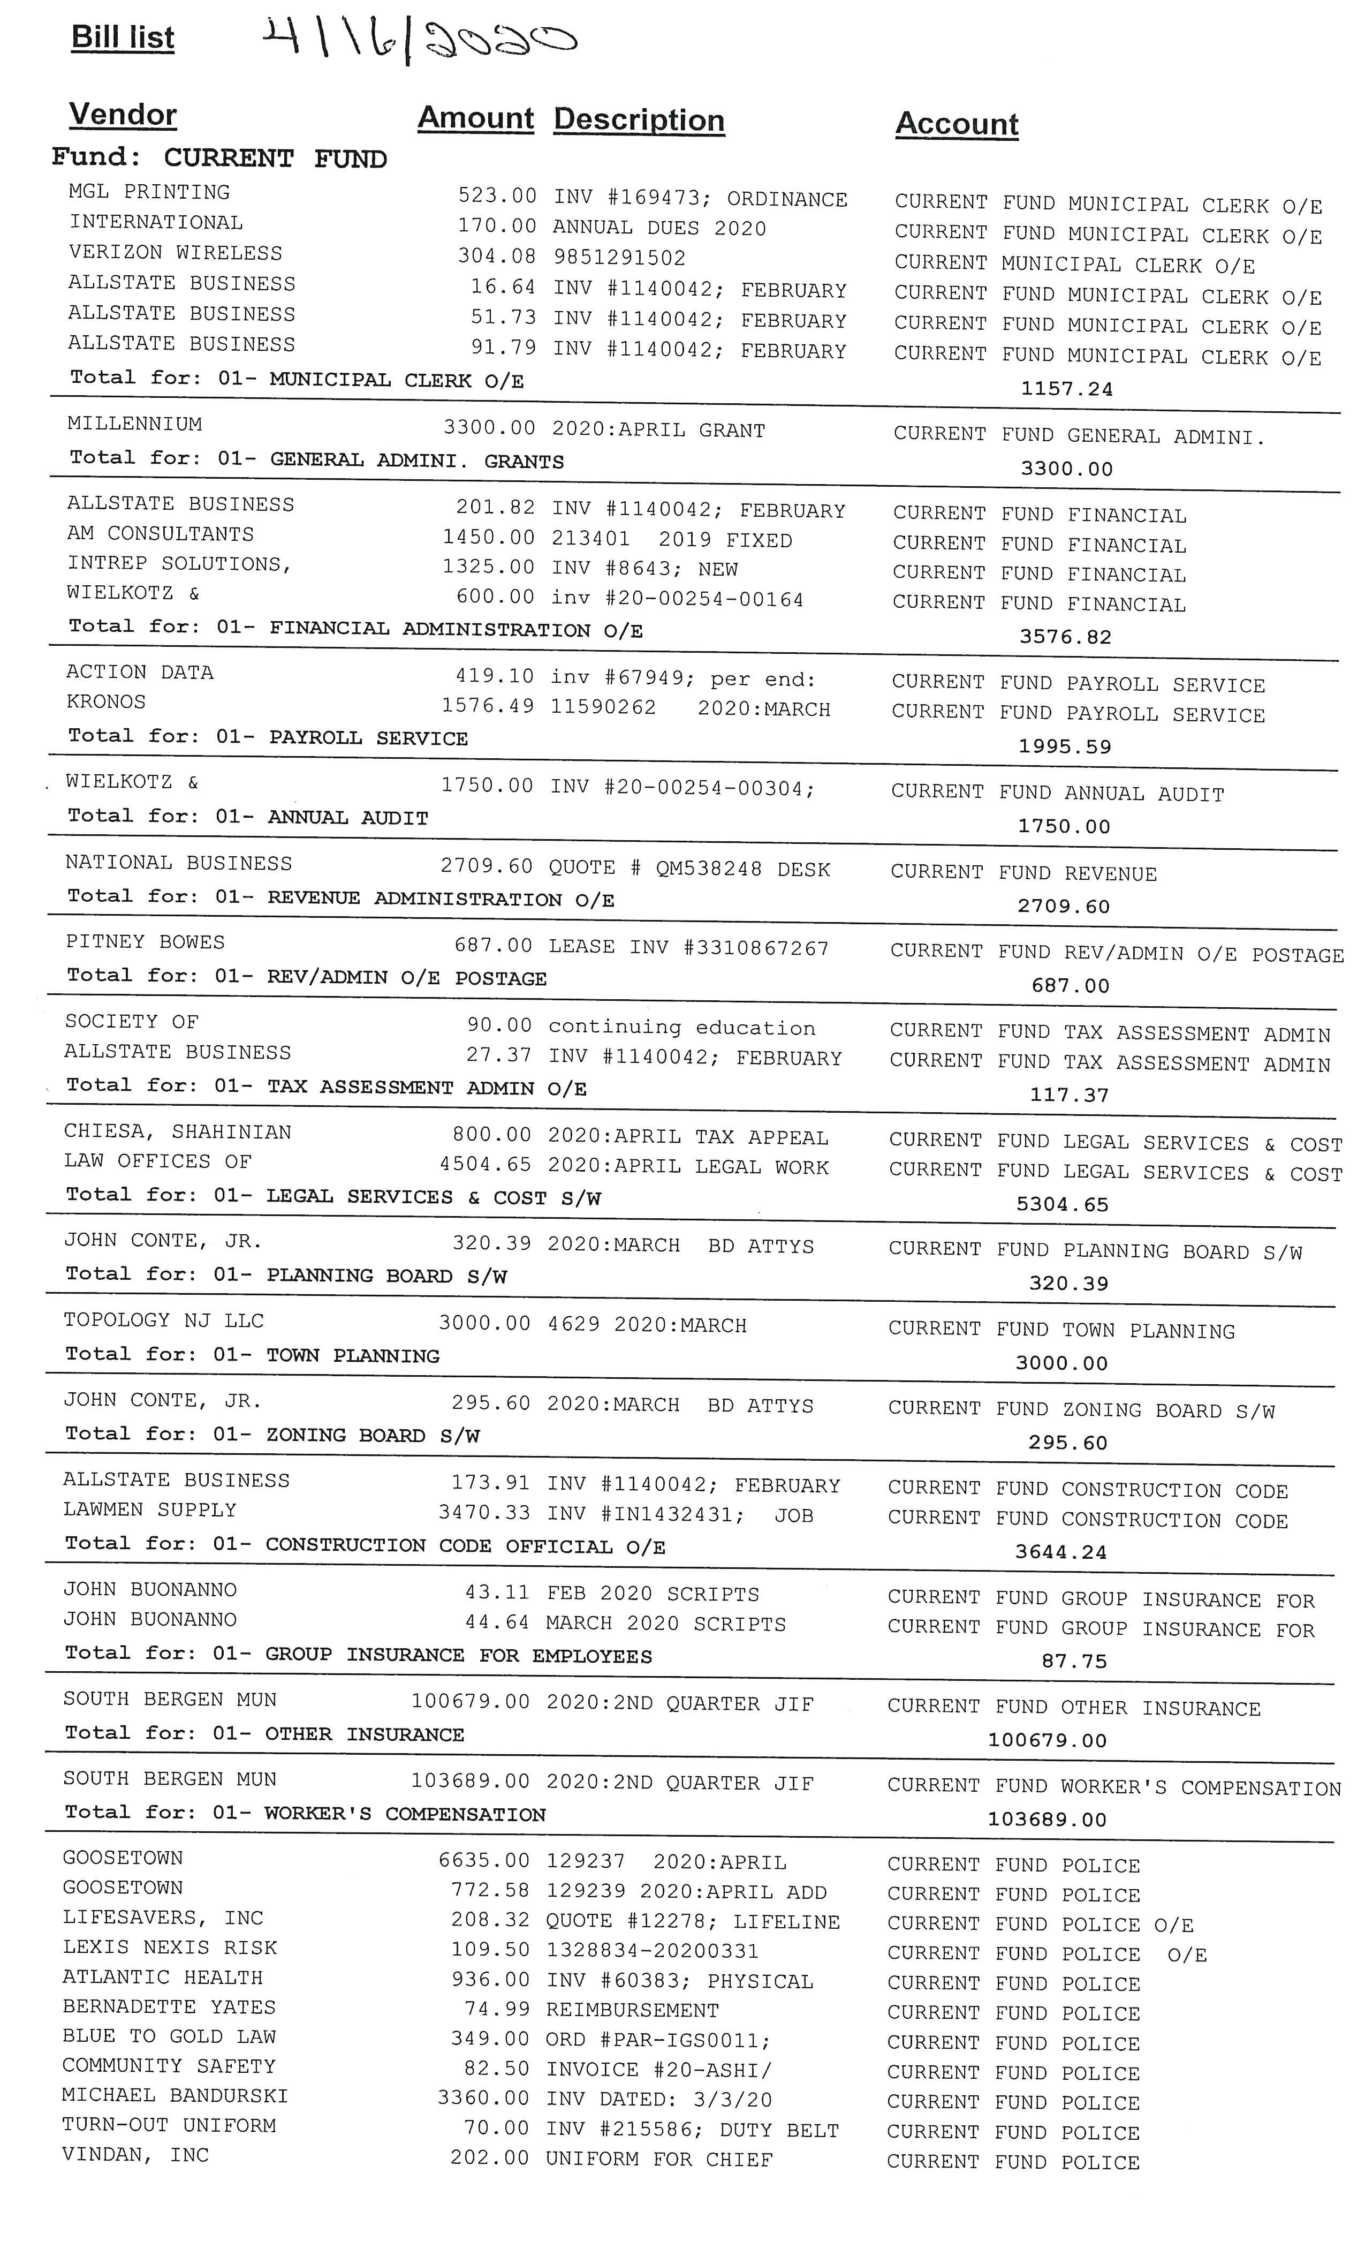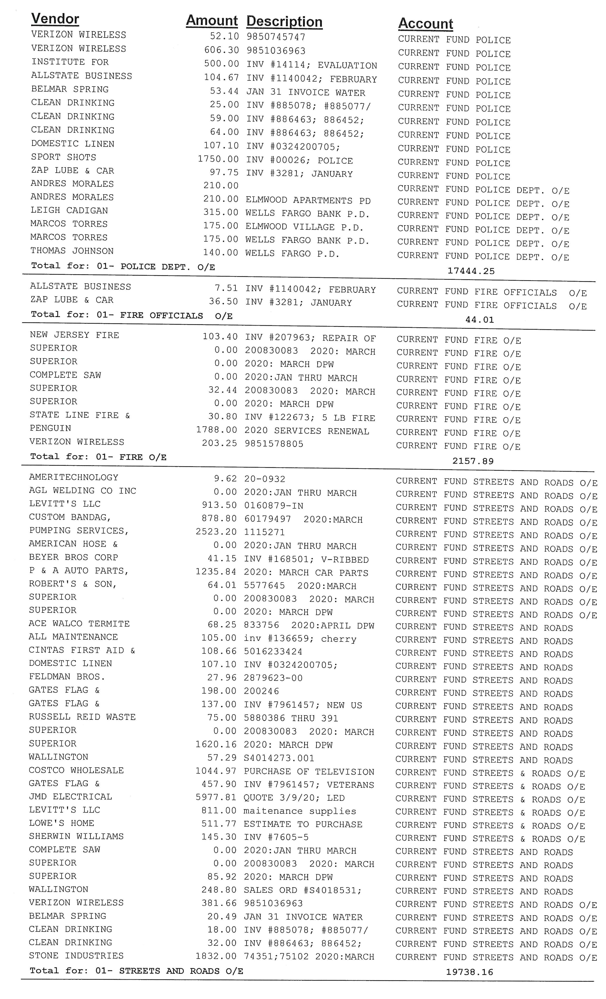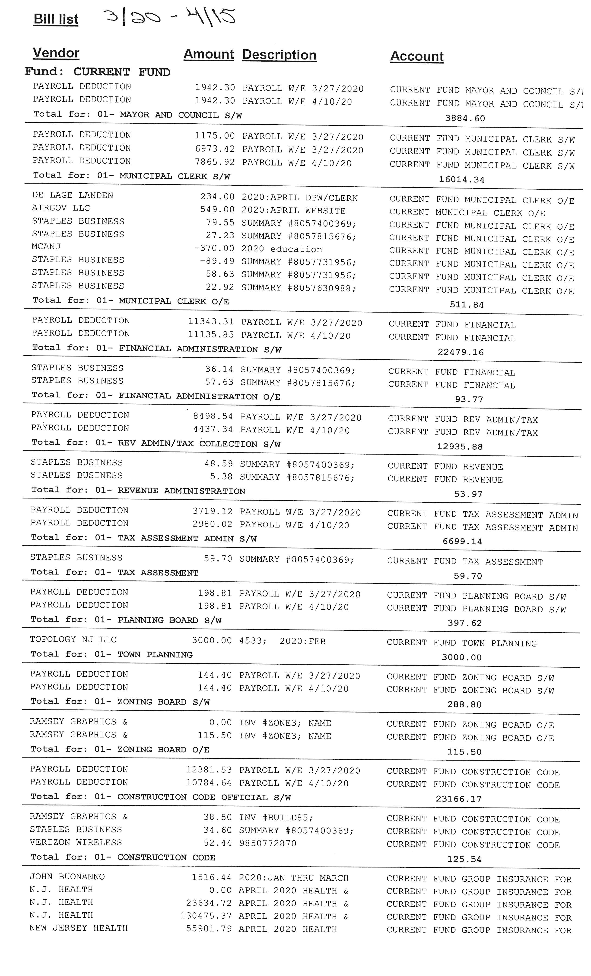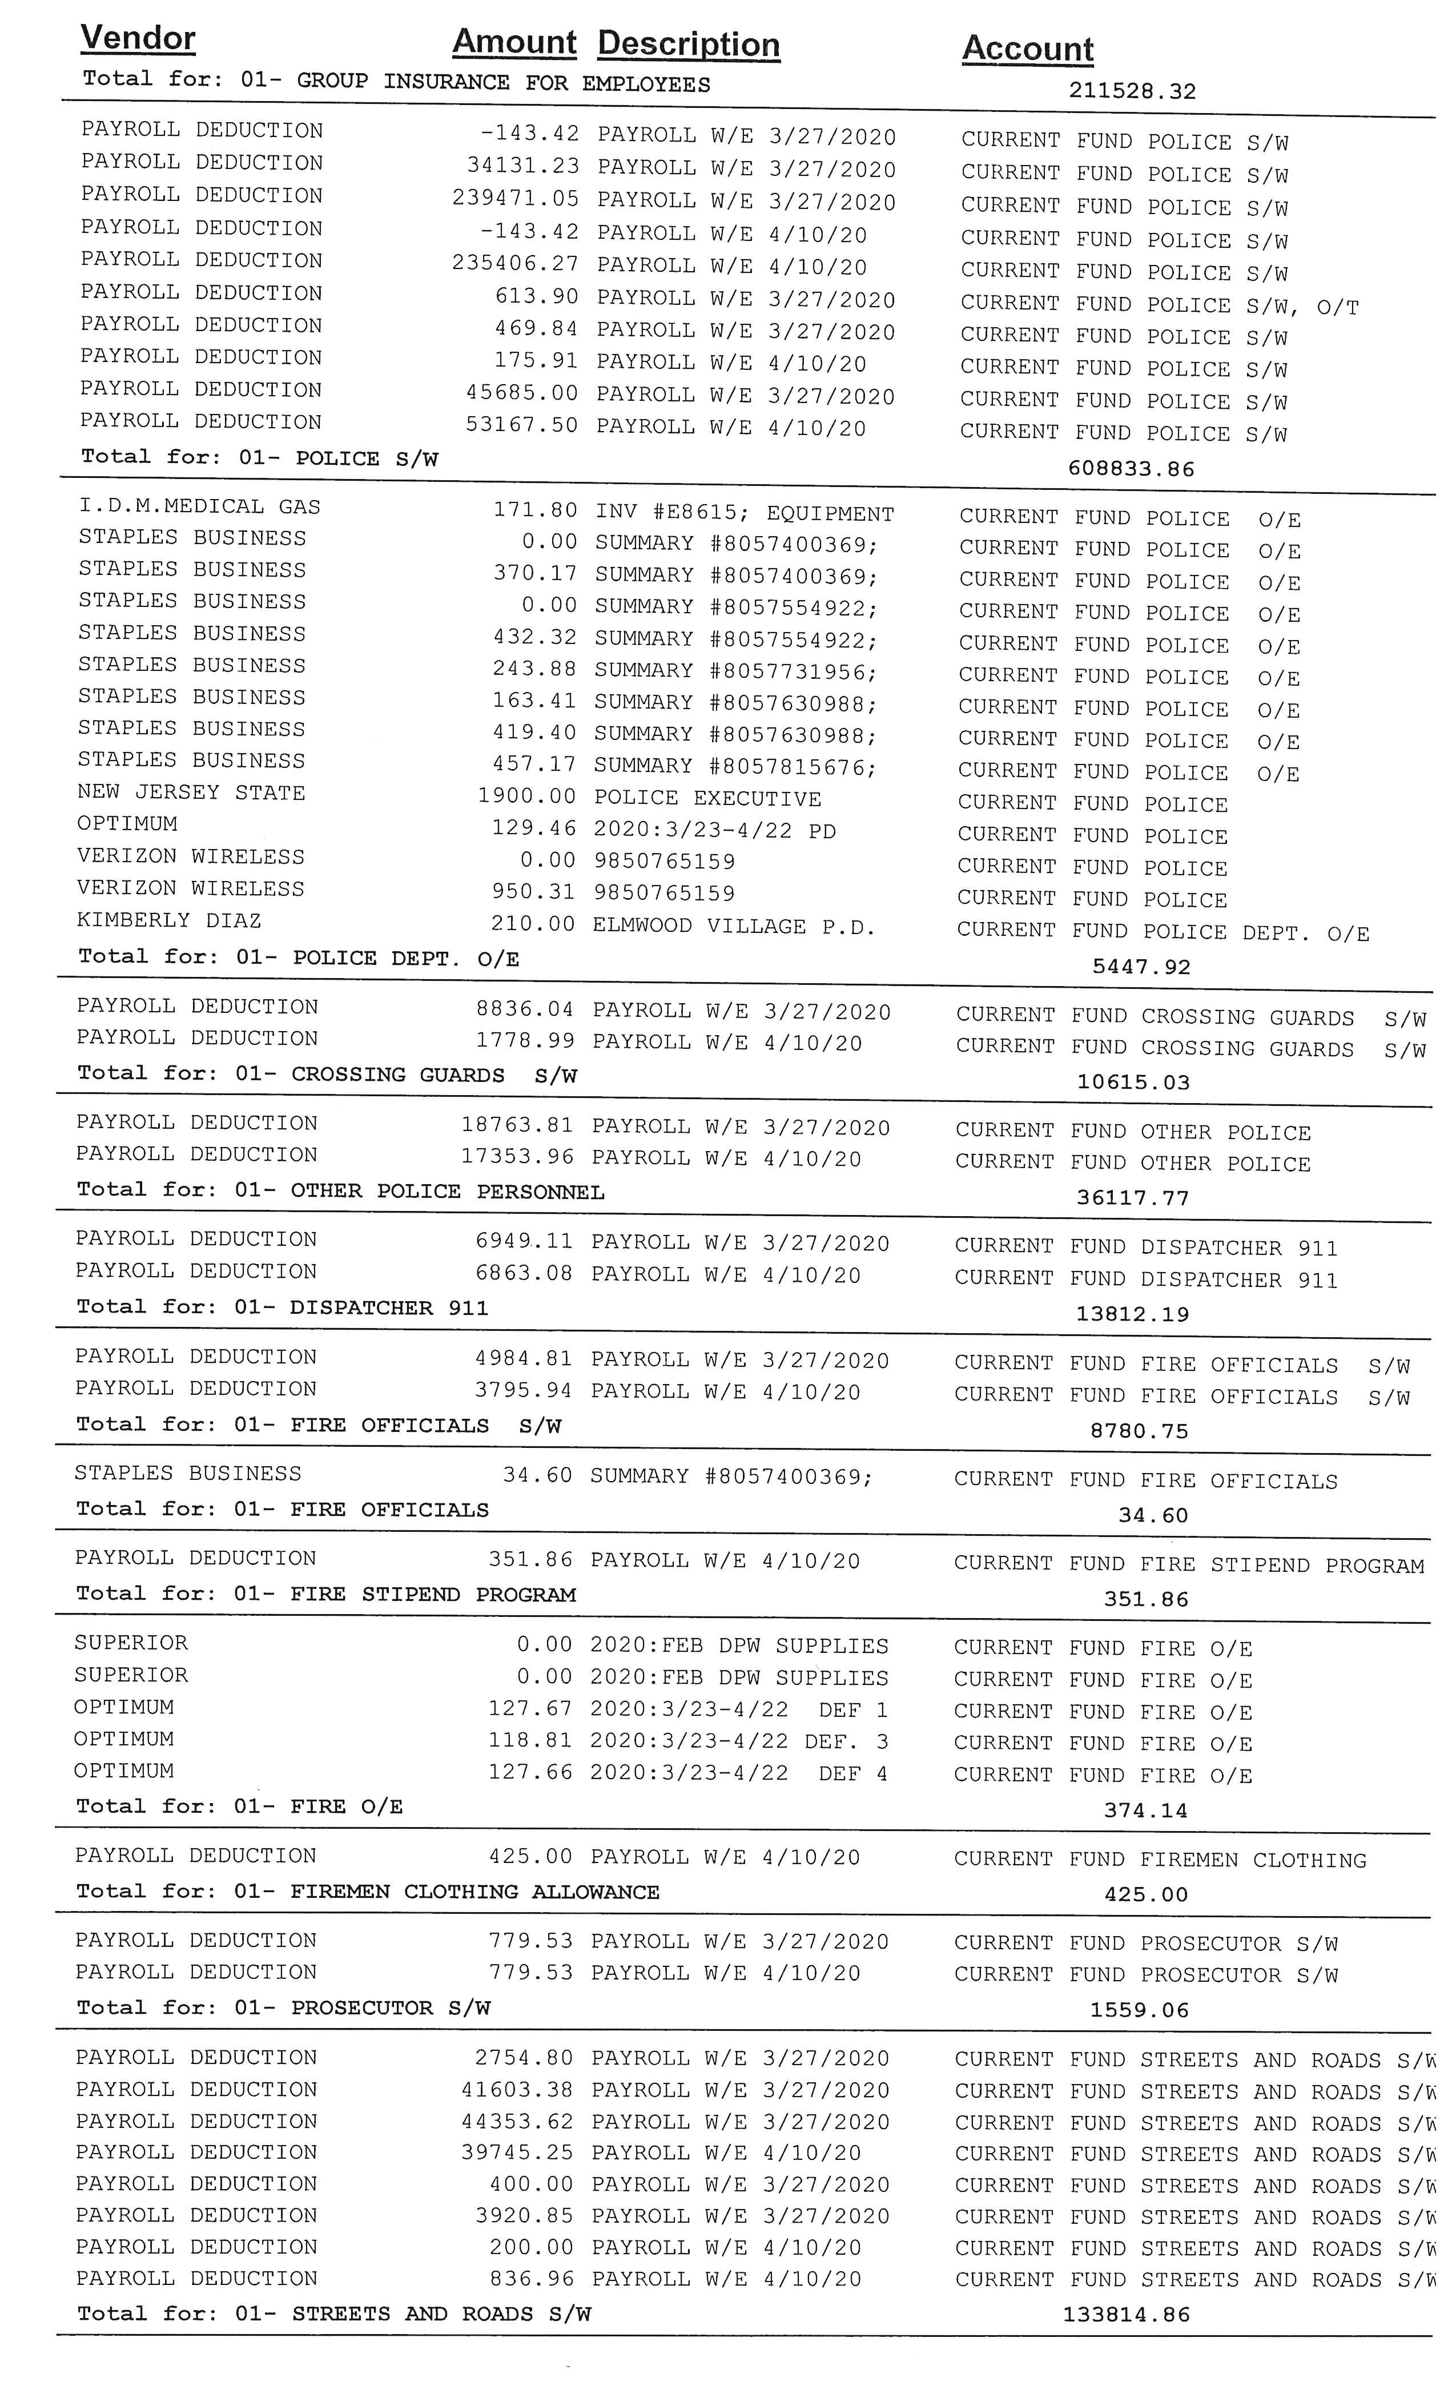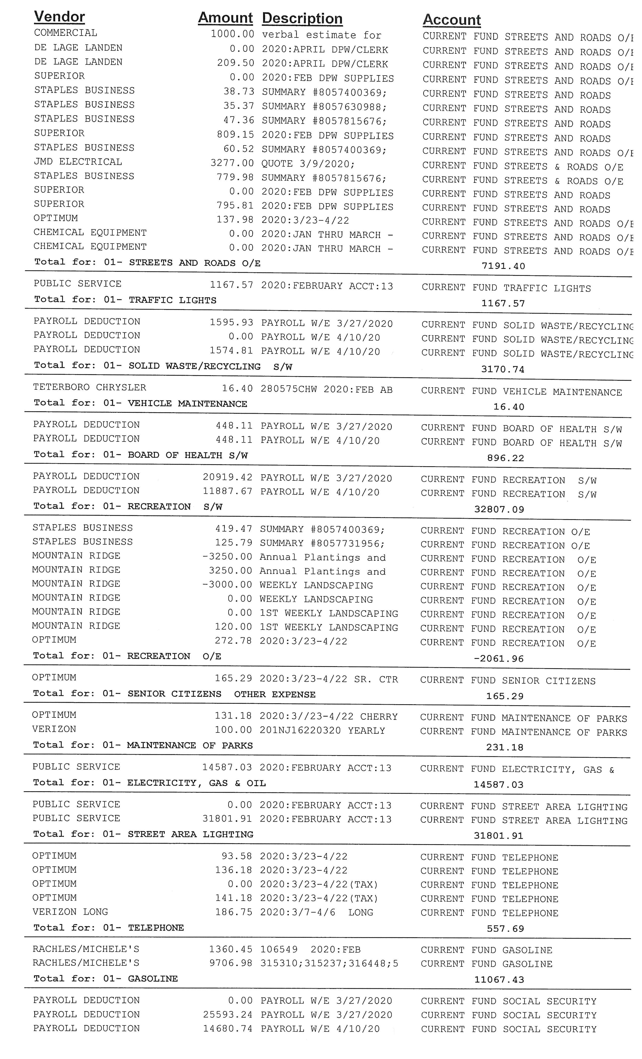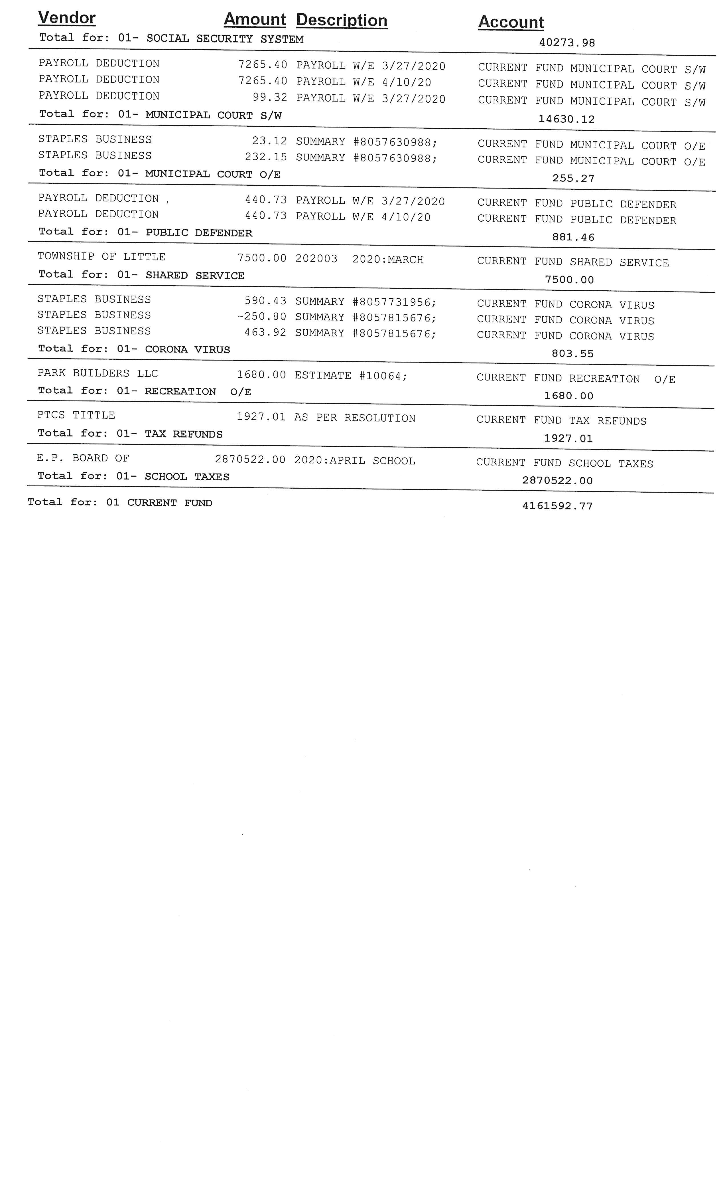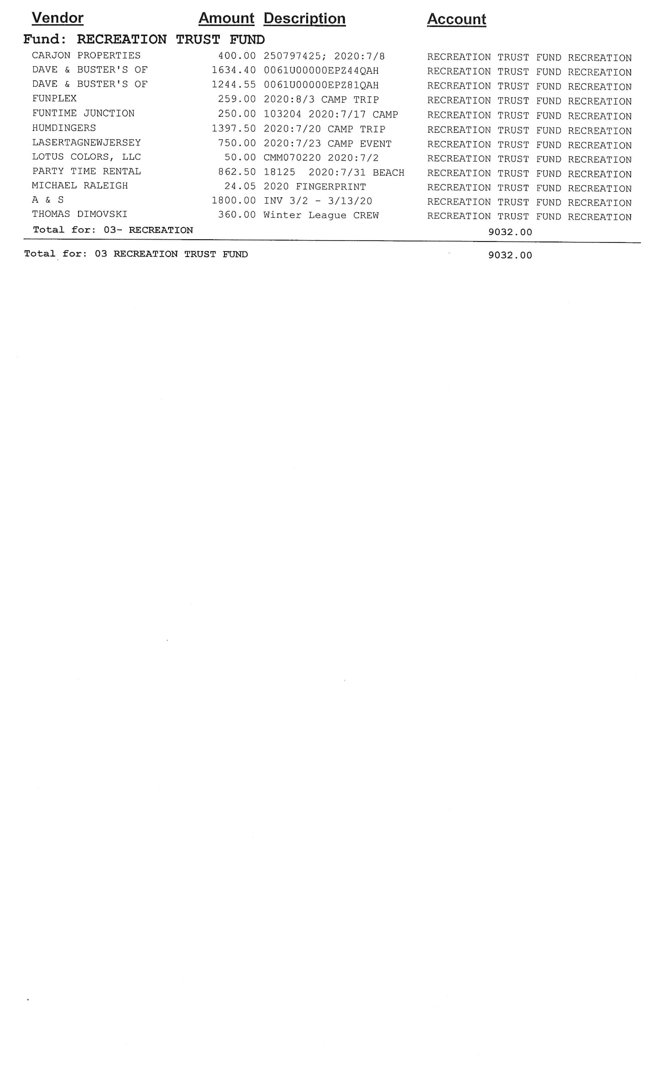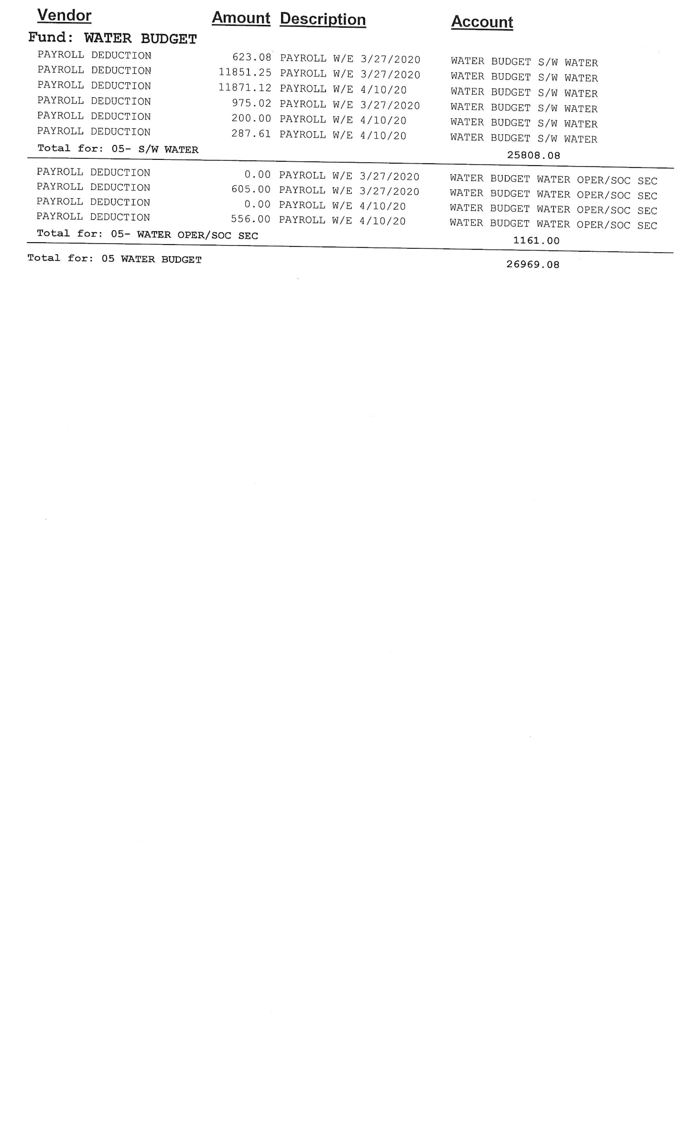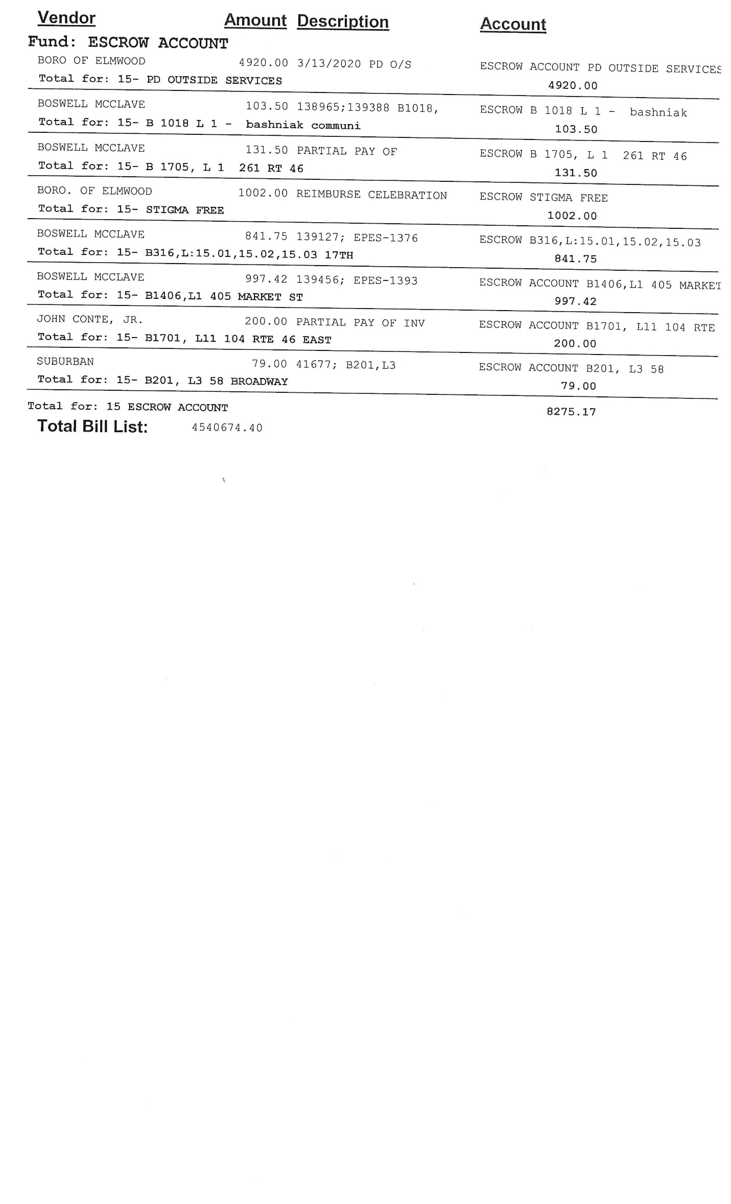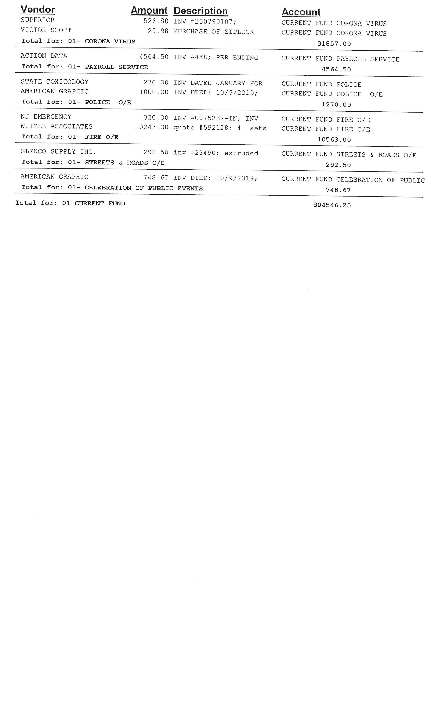BOROUGH OF ELMWOOD PARK
BERGEN COUNTY, NEW JERSEY
RESOLUTION R-180-20
CONSENT AGENDA
RESOLUTION BY:
SECONDED BY:
AUTHORIZE PURCHASE OF EQUIPMENT
WITMER PUBLIC SAFETY GROUP, INC. – FIRE DEPARTMENT
WHEREAS, the Fire Department has requested to purchase equipment for the mini pumper with funds set aside in a Bond Ordinance, specifically, Borough Ordinance 19-11 adopted on final hearing at the Regular Meeting of the Mayor and Council on June 20, 2019; and
WHEREAS, the equipment will be purchased through State Contract 17-FLEET-00767 at an amount of $4,808.25 with Witmer Public Safety Group, Inc. located in Coatesville, PA;
NOW THEREFORE BE IT RESOLVED, by the Mayor and Council of the Borough of Elmwood Park, County of Bergen, State of New Jersey that they hereby authorize the purchase of equipment totaling $4,808.25 with Witmer Public Safety Group, Inc.

I, Roy Riggitano, Chief Financial Officer for the Borough of Elmwood Park do hereby confirm that there are sufficient funds available for this resolution.
________________________________ April 15, 2020
Roy Riggitano, Chief Financial Officer Dated

APPROVED: April 16, 2020
__________________________
Robert Colletti, Mayor
ATTEST: _____________________
Erin Delaney, MPA, RMC
Borough Clerk
Record of Council Vote on Passage
 | AYE | NAY | Abstain | Absent |  | AYE | NAY | Abstain | Absent
Fasolo |  |  |  |  | Pellegrine
Golabek |  |  |  |  | Wechtler
Ingui |  |  |  |  | Balistrieri
This resolution was approved by the Mayor and Council of the Borough of Elmwood Park at a regular scheduled meeting held on the 16th day of April 2020. Signed and sealed before me.
_____________________ _____________________
Erin Delaney, MPA, RMC Dated
Borough Clerk

BOROUGH OF ELMWOOD PARK
BERGEN COUNTY, NEW JERSEY
RESOLUTION R-181-20
CONSENT AGENDA
RESOLUTION BY:
SECONDED BY:
AUTHORIZE PURCHASE OF POLICE SURVEILLANCE
GOOSETOWN COMMUNICATIONS
WHEREAS, the Police Department has requested to purchase surveillance with funds set aside in a Bond Ordinance, specifically, Borough Ordinance 20-04; and
WHEREAS, the equipment will be purchased through State Contract T0109 at an amount of $21,689.40 with Goosetown Communications of Congers, NY;
NOW THEREFORE BE IT RESOLVED, by the Mayor and Council of the Borough of Elmwood Park, County of Bergen, State of New Jersey that they hereby authorize the purchase of surveillance totaling $21,689.40 with Goosetown Communications coming from budget line item 20-04A (A)(II)

I, Roy Riggitano, Chief Financial Officer for the Borough of Elmwood Park do hereby confirm that there are sufficient funds available for this resolution.
________________________________ April 15, 2020
Roy Riggitano, Chief Financial Officer Dated

APPROVED: April 16, 2020
__________________________
Robert Colletti, Mayor
ATTEST: _____________________
Erin Delaney, MPA, RMC
Borough Clerk
Record of Council Vote on Passage
 | AYE | NAY | Abstain | Absent |  | AYE | NAY | Abstain | Absent
Fasolo |  |  |  |  | Pellegrine
Golabek |  |  |  |  | Wechtler
Ingui |  |  |  |  | Balistrieri
This resolution was approved by the Mayor and Council of the Borough of Elmwood Park at a regular scheduled meeting held on the 16th day of April 2020. Signed and sealed before me.
_____________________ _____________________
Erin Delaney, MPA, RMC Dated
Borough Clerk

BOROUGH OF ELMWOOD PARK
BERGEN COUNTY, NEW JERSEY
RESOLUTION R-182-20
CONSENT AGENDA
RESOLUTION BY:
SECONDED BY:
AUTHORIZE PURCHASE OF WHEEL LOAD WEIGHERS
LOADOMETER CORPORATION
POLICE DEPARTMENT
WHEREAS, the Police Department has requested to purchase (2) two-wheel load weighers with funds set aside in a Bond Ordinance, specifically, Borough Ordinance 20-04; and
WHEREAS, the equipment will be purchased at an amount of $5,095 each, totaling $10,190 with Loadometer Corporation of Timonium, MD;
NOW THEREFORE BE IT RESOLVED, by the Mayor and Council of the Borough of Elmwood Park, County of Bergen, State of New Jersey that they hereby authorize the purchase of wheel load weighers totaling $10,190 with Loadometer Corporation coming from budget line item 20-04A (B)(II)(C).

I, Roy Riggitano, Chief Financial Officer for the Borough of Elmwood Park do hereby confirm that there are sufficient funds available for this resolution.
________________________________ April 15, 2020
Roy Riggitano, Chief Financial Officer Dated

APPROVED: April 16, 2020
__________________________
Robert Colletti, Mayor
ATTEST: _____________________
Erin Delaney, MPA, RMC
Borough Clerk
Record of Council Vote on Passage
 | AYE | NAY | Abstain | Absent |  | AYE | NAY | Abstain | Absent
Fasolo |  |  |  |  | Pellegrine
Golabek |  |  |  |  | Wechtler
Ingui |  |  |  |  | Balistrieri
This resolution was approved by the Mayor and Council of the Borough of Elmwood Park at a regular scheduled meeting held on the 16th day of April 2020. Signed and sealed before me.
_____________________ _____________________
Erin Delaney, MPA, RMC Dated
Borough Clerk

BOROUGH OF ELMWOOD PARK
BERGEN COUNTY, NEW JERSEY
RESOLUTION R-183-20
CONSENT AGENDA
RESOLUTION BY:
SECONDED BY:
AUTHORIZE CHANGE ORDER
FIRE DEPARTMENT MINI PUMPER
ABSOLUTE FIRE PROTECTION CO.
WHEREAS, the Fire Department has requested that Current Estimate #1 be approved by the Governing Body as stated below:
Company: Absolute Fire Protection Co.
Resolution #s: R-319-19
Equipment: Fire Department Mini Pumper
Amount of Original Invoice: $239,269.00
Change Order #1: $3,668.00
Total: $242,937.00
NOW THEREFORE BE IT RESOLVED, by the Mayor and Council of the Borough of Elmwood Park that Change Order #1 be approved out of Borough Ordinance 19-11.
I, Roy Riggitano, Chief Financial Officer for the Borough of Elmwood Park do hereby confirm that there are sufficient funds available for this resolution.
________________________________ April 15, 2020
Roy Riggitano, Chief Financial Officer Dated

APPROVED: April 16, 2020
__________________________
Robert Colletti, Mayor
ATTEST: _____________________
Erin Delaney, MPA, RMC
Borough Clerk
Record of Council Vote on Passage
 | AYE | NAY | Abstain | Absent |  | AYE | NAY | Abstain | Absent
Fasolo |  |  |  |  | Pellegrine
Golabek |  |  |  |  | Wechtler
Ingui |  |  |  |  | Balistrieri
This resolution was approved by the Mayor and Council of the Borough of Elmwood Park at a regular scheduled meeting held on the 16th day of April 2020. Signed and sealed before me.
_____________________ _____________________
Erin Delaney, MPA, RMC Dated
Borough Clerk

BOROUGH OF ELMWOOD PARK
BERGEN COUNTY, NEW JERSEY
RESOLUTION R-184-20
CONSENT AGENDA
RESOLUTION BY:
SECONDED BY:
AUTHORIZE RELEASE OF PERFORMANCE CASH AND SURETY BONDS
WHEREAS, applicant located at 662 Market Street, Block 1501, Lot 1 has completed site improvements at the above-referenced location and has requested the release of monies posted for the project; and
WHEREAS, the request has been reviewed by Boswell Engineering and a recommendation has been made for the Borough to authorize said release;
NOW THEREFORE BE IT RESOLVED, by the Mayor and Council of the Borough of Elmwood Park that the following to be released for completion of site work and is hereby authorized as follows:
Performance Cash Bond: $29,280.00
Performance Surety Bond: $263,520.00
Total: $292,800.00

I, Roy Riggitano, Chief Financial Officer for the Borough of Elmwood Park do hereby confirm that there are sufficient funds available for this resolution.
________________________________ April 15, 2020
Roy Riggitano, Chief Financial Officer Dated

APPROVED: April 16, 2020
__________________________
Robert Colletti, Mayor
ATTEST: _____________________
Erin Delaney, MPA, RMC
Borough Clerk
Record of Council Vote on Passage
 | AYE | NAY | Abstain | Absent |  | AYE | NAY | Abstain | Absent
Fasolo |  |  |  |  | Pellegrine
Golabek |  |  |  |  | Wechtler
Ingui |  |  |  |  | Balistrieri
This resolution was approved by the Mayor and Council of the Borough of Elmwood Park at a regular scheduled meeting held on the 16th day of April 2020. Signed and sealed before me.
_____________________ _____________________
Erin Delaney, MPA, RMC Dated
Borough Clerk

BOROUGH OF ELMWOOD PARK
BERGEN COUNTY, NEW JERSEY
RESOLUTION R-185-20
CONSENT AGENDA
RESOLUTION BY:
SECONDED BY:
AUTHORIZE CURRENT ESTIMATE #3 & FINAL
EMERGENCY GENERATOR – RECREATION BUILDING
MANOR II ELECTRIC, INC.
WHEREAS, Boswell Engineering has requested that Current Estimate #3 & Final be approved by the Governing Body as stated below:
Contractor: Manor II Electric, Inc.
File #: EP-1369
PROJECT: Emergency Generator Recreation Building
Total Amount of Work Completed to Date: $135,282.00
Less Zero Percent (2%) Retainage: $0.00
Subtotal: $135,282.00
Less Previous Payments $119,101.33
Total Amount Due Estimate #3 & Final $16,180.67
NOW THEREFORE BE IT RESOLVED, by the Mayor and Council of the Borough of Elmwood Park that Current Estimate #3 & Final be approved and payment of $16,180.67 to Manor II Electric, Inc. for their services is hereby authorized.
I, Roy Riggitano, Chief Financial Officer for the Borough of Elmwood Park do hereby confirm that there are sufficient funds available for this resolution.
________________________________ April 15, 2020
Roy Riggitano, Chief Financial Officer Dated
APPROVED: April 16, 2020
__________________________
Robert Colletti, Mayor
ATTEST: _____________________
Erin Delaney, MPA, RMC
Borough Clerk
Record of Council Vote on Passage
 | AYE | NAY | Abstain | Absent |  | AYE | NAY | Abstain | Absent
Fasolo |  |  |  |  | Pellegrine
Golabek |  |  |  |  | Wechtler
Ingui |  |  |  |  | Balistrieri
This resolution was approved by the Mayor and Council of the Borough of Elmwood Park at a regular scheduled meeting held on the 16th day of April 2020. Signed and sealed before me.
_____________________ _____________________
Erin Delaney, MPA, RMC Dated
Borough Clerk
BOROUGH OF ELMWOOD PARK
BERGEN COUNTY, NEW JERSEY
RESOLUTION R-186-20

CONSENT AGENDA

RESOLUTION BY:
SECONDED BY:

AUTHORIZE PAYMENT FOR CROSSING GUARDS

WHEREAS, since March 16, 2020, schools in Elmwood Park have been closed due to concerns over COVID-19, commonly referred to the coronavirus; and
WHEREAS, since schools have been closed, crossing guards have been out of work without pay; and
WHEREAS, the Borough did pay crossing guards up to 10 days of unused “paid time off” it normally would have paid to guards at the end of the 2019-2020 school year; and
WHEREAS, it appears that schools will remain closed and crossing guards out of work without pay for the foreseeable future while the state, nation and world deal with the current health pandemic; and
WHEREAS, crossing guards are in a unique situation in that they are unable to work because of ordered school closures; and
WHEREAS, certain crossing guards are the only Borough employees who do not meet the weekly threshold to qualify for unemployment insurance benefits; and
WHEREAS, the Mayor and Council deem the non-payment of salary a hardship for those crossing guards who do not qualify for unemployment and, thus, have no other available safety net of wage replacement;
NOW, THEREFORE, BE IT RESOLVED, that the Mayor and Council do hereby authorize the payment of a total amount of One Thousand Dollars ($1,000.00) to be paid in equal installments at normal Borough payroll intervals to each crossing guard employed by the Borough during the 2019-2020 school year who do not qualify for unemployment insurance benefits and for so long as each crossing guard remains in good standing.

I, Roy Riggitano, Chief Financial Officer for the Borough of Elmwood Park do hereby confirm that there are sufficient funds available for this resolution.
________________________________ April 15, 2020
Roy Riggitano, Chief Financial Officer Dated

APPROVED: April 16, 2020
__________________________
Robert Colletti, Mayor
ATTEST: _____________________
Erin Delaney, MPA, RMC
Borough Clerk

Record of Council Vote on Passage
 | AYE | NAY | Abstain | Absent |  | AYE | NAY | Abstain | Absent
Fasolo |  |  |  |  | Pellegrine
Golabek |  |  |  |  | Wechtler
Ingui |  |  |  |  | Balistrieri
This resolution was approved by the Mayor and Council of the Borough of Elmwood Park at a regular scheduled meeting held on the 16th day of April 2020. Signed and sealed before me.
_____________________ _____________________
Erin Delaney, MPA, RMC Dated
Borough Clerk

BOROUGH OF ELMWOOD PARK
BERGEN COUNTY, NEW JERSEY
RESOLUTION R-187-20

CONSENT AGENDA

RESOLUTION BY:
SECONDED BY:

AUTHORIZE MONTHLY PAYMENT FOR CLEANING SERVICES
RECREATION DEPARTMENT – OPEN WORKS
WHEREAS, the Recreation Director has made a request for cleaning services as it is necessary to sanitize the Recreation/Senior Citizen building from time to time; and
WHEREAS, the Recreation Director has recommended Open Works as a vendor, who has a proven record in accomplishing said task within the Borough; and
WHEREAS a written quote of $634.00 per month at a rate of once a week was submitted; and
WHEREAS, Open Works also has an OSHA rating which further supports this resolution; and
NOW THEREFORE BE IT RESOLVED, that the Qualified Purchasing Agent has reviewed with the Borough Administrator and the Recreation Director said resolution and hereby recommends the award on a month to month basis to Open Works at a monthly fee of $634.00.
BE IT FURTHER RESOLVED, that the Mayor and Council do hereby authorize the payment of a total amount of $634.00 per month to Open Works for the sanitizing of the Recreation/Senior Citizen building coming from the Recreation Department budget.
I, Roy Riggitano, Chief Financial Officer for the Borough of Elmwood Park do hereby confirm that there are sufficient funds available for this resolution.
________________________________ April 15, 2020
Roy Riggitano, Chief Financial Officer Dated

APPROVED: April 16, 2020
__________________________
Robert Colletti, Mayor
ATTEST: _____________________
Erin Delaney, MPA, RMC
Borough Clerk
Record of Council Vote on Passage
 | AYE | NAY | Abstain | Absent |  | AYE | NAY | Abstain | Absent
Fasolo |  |  |  |  | Pellegrine
Golabek |  |  |  |  | Wechtler
Ingui |  |  |  |  | Balistrieri
This resolution was approved by the Mayor and Council of the Borough of Elmwood Park at a regular scheduled meeting held on the 16th day of April 2020. Signed and sealed before me.
_____________________ _____________________
Erin Delaney, MPA, RMC Dated
Borough Clerk
BOROUGH OF ELMWOOD PARK
BERGEN COUNTY, NEW JERSEY
RESOLUTION R-188-20

CONSENT AGENDA

RESOLUTION BY:
SECONDED BY:

APPROVE SICK/VACATION BUYBACK REQUEST
WHEREAS, Scott Karcz, Superintendent of the Department of Works has requested to buy back banked sick and vacation time accrued over the years; and
WHEREAS, Scott Karcz has agreed to buy back 400 hours in sick time and 200 hours in vacation time which has been reviewed and approved by the Chief Financial Officer; and
WHEREAS, the Chief Financial Officer has reviewed the salary and has computed the value of $25,131.56 Sick Time and $12,565.78 Vacation Time for a total of $37,697.35 and recommends that said funds be paid through the Compensation Trust Fund;
NOW THEREFORE BE IT RESOLVED, by the Mayor and Council of the Borough of Elmwood Park that a payment to Scott Karcz in the total amount of $37,697.35 be and is hereby approved.

I, Roy Riggitano, Chief Financial Officer for the Borough of Elmwood Park do hereby confirm that there are sufficient funds available for this resolution.
________________________________ April 15, 2020
Roy Riggitano, Chief Financial Officer Dated

APPROVED: April 16, 2020
__________________________
Robert Colletti, Mayor
ATTEST: _____________________
Erin Delaney, MPA, RMC
Borough Clerk

Record of Council Vote on Passage
 | AYE | NAY | Abstain | Absent |  | AYE | NAY | Abstain | Absent
Fasolo |  |  |  |  | Pellegrine
Golabek |  |  |  |  | Wechtler
Ingui |  |  |  |  | Balistrieri
This resolution was approved by the Mayor and Council of the Borough of Elmwood Park at a regular scheduled meeting held on the 16th day of April 2020. Signed and sealed before me.
_____________________ _____________________
Erin Delaney, MPA, RMC Dated
Borough Clerk
BOROUGH OF ELMWOOD PARK
BERGEN COUNTY, NEW JERSEY
RESOLUTION R-189-20

CONSENT AGENDA

RESOLUTION BY:
SECONDED BY:

AWARD OF BID – FY2018 NJDOT MUNICIPAL AID PROGRAM
MOLA BOULEVARD
YOUR WAY CONSTRUCTION, INC.

WHEREAS, the Mayor and Council of the Borough of Elmwood Park, County of Bergen, State of New Jersey solicited bid proposals on Thursday, March 19th, 2020 for the FY2018 NJDOT Municipal Aid Program, of which a $212,000.00 was secured; and
WHEREAS, the Bid Opening Committee did receive 5 bids pursuant to the advertisement for the above project; and
WHEREAS, the proposals were opened on Wednesday, April 1st, 2020 and the results are as follows;
Contractors Bid
4 Clean-up Inc. $208,468.50
American Asphalt $208,315.15
D & L Paving Contractors, Inc. $226,693.95
D.L.S. Contracting, Inc. $298,368.00
Your Way Construction, Inc. $194,935.49
WHEREAS, the bids submitted have been reviewed by the Qualified Purchasing Agent, Borough Attorney and Borough Engineer and is in compliance with the New Jersey Local Public Contract Law, and it is the recommendation of the Mayor and Council that the above-mentioned project be awarded to Your Way Construction, Inc. in the amount of $194,935.49be and is hereby awarded; and
NOW THEREFORE BE IT RESOLVED, by the Mayor and Council of the Borough of Elmwood Park, County of Bergen, State of New Jersey that the bid submitted by Your Way Construction, Inc. in the amount $194,935.49 funded through Bond Ordinance 20-04B be and is hereby awarded; and
BE IT FURTHER RESOLVED, that Mayor Robert Colletti and Borough Clerk Erin N. Delaney are hereby authorized to execute said contract.

I, Roy Riggitano, Chief Financial Officer for the Borough of Elmwood Park do hereby confirm that there are sufficient funds available for this resolution.
________________________________ April 15, 2020
Roy Riggitano, Chief Financial Officer Dated

APPROVED: April 16, 2020
__________________________
Robert Colletti, Mayor
ATTEST: _____________________
Erin Delaney, MPA, RMC
Borough Clerk

Record of Council Vote on Passage
 | AYE | NAY | Abstain | Absent |  | AYE | NAY | Abstain | Absent
Fasolo |  |  |  |  | Pellegrine
Golabek |  |  |  |  | Wechtler
Ingui |  |  |  |  | Balistrieri
This resolution was approved by the Mayor and Council of the Borough of Elmwood Park at a regular scheduled meeting held on the 16th day of April 2020. Signed and sealed before me.
_____________________ _____________________
Erin Delaney, MPA, RMC Dated
Borough Clerk

BOROUGH OF ELMWOOD PARK
BERGEN COUNTY, NEW JERSEY
RESOLUTION R-190-20

CONSENT AGENDA

RESOLUTION BY:
SECONDED BY:
AUTHORIZE EMERGENCY REPAIR SERVICES
COLONNELLI BROS., INC.
WHEREAS, on March 15, 2020 the Department of Public Works reported an emergency sewer main issue on Mola Boulevard; and
WHEREAS, it was determined that the Department of Public Works did not have the resources to complete the repair; and
WHEREAS, Colonnelli Bros., Inc. was contacted by the Department of Public Works Superintendent to complete the repair with the authorization of the Borough Administrator and CFO upon declaring an emergency situation;
NOW THEREFORE BE IT RESOLVED, by the Mayor and Council of the Borough of Elmwood Park hereby approve the emergency sewer main repair costs not to exceed $68,249.95 for the completed repairs.

I, Roy Riggitano, Chief Financial Officer for the Borough of Elmwood Park do hereby confirm that there are sufficient funds available for this resolution.
________________________________ April 15, 2020
Roy Riggitano, Chief Financial Officer Dated

APPROVED: April 16, 2020
__________________________
Robert Colletti, Mayor
ATTEST: _____________________
Erin Delaney, MPA, RMC
Borough Clerk

Record of Council Vote on Passage
 | AYE | NAY | Abstain | Absent |  | AYE | NAY | Abstain | Absent
Fasolo |  |  |  |  | Pellegrine
Golabek |  |  |  |  | Wechtler
Ingui |  |  |  |  | Balistrieri
This resolution was approved by the Mayor and Council of the Borough of Elmwood Park at a regular scheduled meeting held on the 16th day of April 2020. Signed and sealed before me.
_____________________ _____________________
Erin Delaney, MPA, RMC Dated
Borough Clerk

BOROUGH OF ELMWOOD PARK
BERGEN COUNTY, NEW JERSEY
RESOLUTION R-191-20

CONSENT AGENDA

RESOLUTION BY:
SECONDED BY:
AUTHORIZE EMERGENCY PURCHASE
SEWER IMPROVEMENTS
PUMPING SERVICES, INC.
WHEREAS, on March 30, 2020 the Department of Public Works Superintendent was required to make an emergency purchase for pending sewer improvements previously discussed with the Governing Body;
WHEREAS, the Superintendent made the purchase with Pumping Services, Inc. with the authorization of the Borough Administrator and CFO upon declaring an emergency situation;
NOW THEREFORE BE IT RESOLVED, by the Mayor and Council of the Borough of Elmwood Park hereby approve the emergency purchase at a cost not to exceed $155,000.

I, Roy Riggitano, Chief Financial Officer for the Borough of Elmwood Park do hereby confirm that there are sufficient funds available for this resolution.
________________________________ April 15, 2020
Roy Riggitano, Chief Financial Officer Dated

APPROVED: April 16, 2020
__________________________
Robert Colletti, Mayor
ATTEST: _____________________
Erin Delaney, MPA, RMC
Borough Clerk

Record of Council Vote on Passage
 | AYE | NAY | Abstain | Absent |  | AYE | NAY | Abstain | Absent
Fasolo |  |  |  |  | Pellegrine
Golabek |  |  |  |  | Wechtler
Ingui |  |  |  |  | Balistrieri
This resolution was approved by the Mayor and Council of the Borough of Elmwood Park at a regular scheduled meeting held on the 16th day of April 2020. Signed and sealed before me.
_____________________ _____________________
Erin Delaney, MPA, RMC Dated
Borough Clerk

BOROUGH OF ELMWOOD PARK
BERGEN COUNTY, NEW JERSEY
RESOLUTION R-192-20
CONSENT AGENDA
RESOLUTION BY:
SECONDED BY:
APPOINT GYM SUPERVISOR
GABRIELA YILATOPA
RECREATION DEPARTMENT

WHEREAS, the Recreation Department of the Borough of Elmwood Park has recognized the need to fill one position of a Gym Supervisor; and

WHEREAS, it is the recommendation of the Recreation Director to appoint the following named as a Gym Supervisor at a rate of $14.00 per hour;

NOW THEREFORE, BE IT RESOLVED, by the Mayor and Council of the Borough of Elmwood Park that the following named be and is hereby appointed as a Gym Supervisor effective immediately:
Gabriela Yilatopa

I, Roy Riggitano, Chief Financial Officer for the Borough of Elmwood Park do hereby confirm that there are sufficient funds available for this resolution.
________________________________ April 15, 2020
Roy Riggitano, Chief Financial Officer Dated

APPROVED: April 16, 2020
__________________________
Robert Colletti, Mayor
ATTEST: _____________________
Erin Delaney, MPA, RMC
Borough Clerk

Record of Council Vote on Passage
 | AYE | NAY | Abstain | Absent |  | AYE | NAY | Abstain | Absent
Fasolo |  |  |  |  | Pellegrine
Golabek |  |  |  |  | Wechtler
Ingui |  |  |  |  | Balistrieri
This resolution was approved by the Mayor and Council of the Borough of Elmwood Park at a regular scheduled meeting held on the 16th day of April 2020. Signed and sealed before me.
_____________________ _____________________
Erin Delaney, MPA, RMC Dated
Borough Clerk

BOROUGH OF ELMWOOD PARK
BERGEN COUNTY, NEW JERSEY
RESOLUTION R-193-20
CONSENT AGENDA
RESOLUTION BY:
SECONDED BY:
AUTHORIZE THE EXECUTION OF IT PROFESSIONAL CONSULTING CONTRACT
INTREP SOLUTIONS LLC
WHEREAS, at the March 19, 2020 Meeting of the Mayor and Council Intrep Solutions, LLC. was appointed as the Borough IT Professional;
THEREFORE, BE IT RESOLVED, by the Mayor and Council of the Borough of Elmwood Park that Mayor Robert Colletti and Borough Clerk Erin Delaney are hereby authorized to execute the professional consulting contract between the Borough of Elmwood Park and Intrep Solutions, LLC.

I, Roy Riggitano, Chief Financial Officer for the Borough of Elmwood Park do hereby confirm that there are sufficient funds available for this resolution.
________________________________ April 15, 2020
Roy Riggitano, Chief Financial Officer Dated

APPROVED: April 16, 2020
__________________________
Robert Colletti, Mayor
ATTEST: _____________________
Erin Delaney, MPA, RMC
Borough Clerk

Record of Council Vote on Passage
 | AYE | NAY | Abstain | Absent |  | AYE | NAY | Abstain | Absent
Fasolo |  |  |  |  | Pellegrine
Golabek |  |  |  |  | Wechtler
Ingui |  |  |  |  | Balistrieri
This resolution was approved by the Mayor and Council of the Borough of Elmwood Park at a regular scheduled meeting held on the 16th day of April 2020. Signed and sealed before me.
_____________________ _____________________
Erin Delaney, MPA, RMC Dated
Borough Clerk

BOROUGH OF ELMWOOD PARK
BERGEN COUNTY, NEW JERSEY
RESOLUTION R-194-20
CONSENT AGENDA
RESOLUTION BY:
SECONDED BY:
AUTHORIZE PAYMENT - SERVPRO

WHEREAS, the Borough Administrator has requested payment to Servpro of Paramus for their services of cleaning and deodorizing Borough buildings during a state of emergency; and
WHEREAS, Servpro of Paramus has completed all necessary Pay-to-Play paperwork and submitted an invoice in the amount of $21,235.62 for their services;
NOW THEREFORE BE IT RESOLVED, by the Mayor and Council of the Borough of Elmwood Park, County of Bergen, State of New Jersey that they hereby authorize payment to Servpro of Paramus in the amount of $21,235.62 out of the “Corona Virus” budget line item.

I, Roy Riggitano, Chief Financial Officer for the Borough of Elmwood Park do hereby confirm that there are sufficient funds available for this resolution.
________________________________ April 15, 2020
Roy Riggitano, Chief Financial Officer Dated

APPROVED: April 16, 2020
__________________________
Robert Colletti, Mayor
ATTEST: _____________________
Erin Delaney, MPA, RMC
Borough Clerk

Record of Council Vote on Passage
 | AYE | NAY | Abstain | Absent |  | AYE | NAY | Abstain | Absent
Fasolo |  |  |  |  | Pellegrine
Golabek |  |  |  |  | Wechtler
Ingui |  |  |  |  | Balistrieri
This resolution was approved by the Mayor and Council of the Borough of Elmwood Park at a regular scheduled meeting held on the 16th day of April 2020. Signed and sealed before me.
_____________________ _____________________
Erin Delaney, MPA, RMC Dated
Borough Clerk

BOROUGH OF ELMWOOD PARK
BERGEN COUNTY, NEW JERSEY
RESOLUTION R-195-20
CONSENT AGENDA
RESOLUTION BY:
SECONDED BY:
AUTHORIZE ADDITIONAL FUNDING – SPECIAL LEGAL COUNSEL
POLICE DEPARTMENT
APRUZZESE, MCDERMOTT, MASTRO & MURPHY, P.C.
WHEREAS, the Mayor and Council of the Borough of Elmwood Park appointed Special Legal Counsel for the Police Department at their April 20, 2017 Regular Meeting; and
WHEREAS, additional funding is needed as there has yet to be a conclusion to various labor matters; and
WHEREAS, an additional amount of $50,000 is being requested for all future invoices;
NOW THEREFORE BE IT RESOLVED, by the Mayor and Council of the Borough of Elmwood Park, County of Bergen, State of New Jersey, that additional funding with a not to exceed amount of $50,000 for Apruzzese, McDermott, Mastro & Murphy, P.C. (Arthur Thibault Jr., Esq.) as Special Labor Counsel be approved.

I, Roy Riggitano, Chief Financial Officer for the Borough of Elmwood Park do hereby confirm that there are sufficient funds available for this resolution.
________________________________ April 15, 2020
Roy Riggitano, Chief Financial Officer Dated

APPROVED: April 16, 2020
__________________________
Robert Colletti, Mayor
ATTEST: _____________________
Erin Delaney, MPA, RMC
Borough Clerk

Record of Council Vote on Passage
 | AYE | NAY | Abstain | Absent |  | AYE | NAY | Abstain | Absent
Fasolo |  |  |  |  | Pellegrine
Golabek |  |  |  |  | Wechtler
Ingui |  |  |  |  | Balistrieri
This resolution was approved by the Mayor and Council of the Borough of Elmwood Park at a regular scheduled meeting held on the 16th day of April 2020. Signed and sealed before me.
_____________________ _____________________
Erin Delaney, MPA, RMC Dated
Borough Clerk
BOROUGH OF ELMWOOD PARK
BERGEN COUNTY, NEW JERSEY
RESOLUTION R-196-20
CONSENT AGENDA
RESOLUTION BY:
SECONDED BY:
AUTHORIZE NOT TO EXCEED AMOUNT – SPECIAL LEGAL COUNSEL
APRUZZESE, MCDERMOTT, MASTRO & MURPHY, P.C.
WHEREAS, the Mayor and Council of the Borough of Elmwood Park appointed Special Legal Counsel for Borough Personnel Matters via Resolution R-109-20 on February 27, 2020; and
WHEREAS, the Mayor and Council have deemed it necessary that a not to exceed amount of $20,000.00 be established for their services starting April 1, 2020 through December 31, 2020;
NOW THEREFORE BE IT RESOLVED, by the Mayor and Council of the Borough of Elmwood Park, County of Bergen, State of New Jersey, that a not to exceed amount of $20,000.00 be established for Special Legal Counsel to Apruzzese, McDermott, Mastro & Murphy, P.C. and is hereby approved.

I, Roy Riggitano, Chief Financial Officer for the Borough of Elmwood Park do hereby confirm that there are sufficient funds available for this resolution.
________________________________ April 15, 2020
Roy Riggitano, Chief Financial Officer Dated

APPROVED: April 16, 2020
__________________________
Robert Colletti, Mayor
ATTEST: _____________________
Erin Delaney, MPA, RMC
Borough Clerk

Record of Council Vote on Passage
 | AYE | NAY | Abstain | Absent |  | AYE | NAY | Abstain | Absent
Fasolo |  |  |  |  | Pellegrine
Golabek |  |  |  |  | Wechtler
Ingui |  |  |  |  | Balistrieri
This resolution was approved by the Mayor and Council of the Borough of Elmwood Park at a regular scheduled meeting held on the 16th day of April 2020. Signed and sealed before me.
_____________________ _____________________
Erin Delaney, MPA, RMC Dated
Borough Clerk

BOROUGH OF ELMWOOD PARK
BERGEN COUNTY, NEW JERSEY
RESOLUTION R-197-20
CONSENT AGENDA
RESOLUTION BY:
SECONDED BY:
RESOLUTION APPROVING ELMWOOD PARK FIRE DEPARTMENT STIPEND PROGRAM – 1st QUARTER COMPENSATION
WHEREAS, the Mayor and Council of the Borough of Elmwood Park, Bergen County, New Jersey, has adopted Ordinance #16-21 implementing stipend program for the Elmwood Park Fire Department on November 10, 2016; and
WHEREAS, the Fire Chief has reviewed and has forwarded a certified list to the Mayor and Council who have met the minimum requirements to receive such funds; and
WHEREAS, a certified list containing the names of the recipients are attached to this resolution in which the auditors have recommended in the audit that this list be available for review in the form of a resolution; and
THEREFORE, BE IT RESOLVED, that the Chief Financial Officer, has certified funds were available totaling $32,416.82 for the Volunteer Fire Department and that the Mayor and Council hereby authorized the payment of said stipends.

I, Roy Riggitano, Chief Financial Officer for the Borough of Elmwood Park do hereby confirm that there are sufficient funds available for this resolution.
________________________________ April 15, 2020
Roy Riggitano, Chief Financial Officer Dated

APPROVED: April 16, 2020
__________________________
Robert Colletti, Mayor
ATTEST: _____________________
Erin Delaney, MPA, RMC
Borough Clerk
Record of Council Vote on Passage
 | AYE | NAY | Abstain | Absent |  | AYE | NAY | Abstain | Absent
Fasolo |  |  |  |  | Pellegrine
Golabek |  |  |  |  | Wechtler
Ingui |  |  |  |  | Balistrieri
This resolution was approved by the Mayor and Council of the Borough of Elmwood Park at a regular scheduled meeting held on the 16th day of April 2020. Signed and sealed before me.
_____________________ _____________________
Erin Delaney, MPA, RMC Dated
Borough Clerk

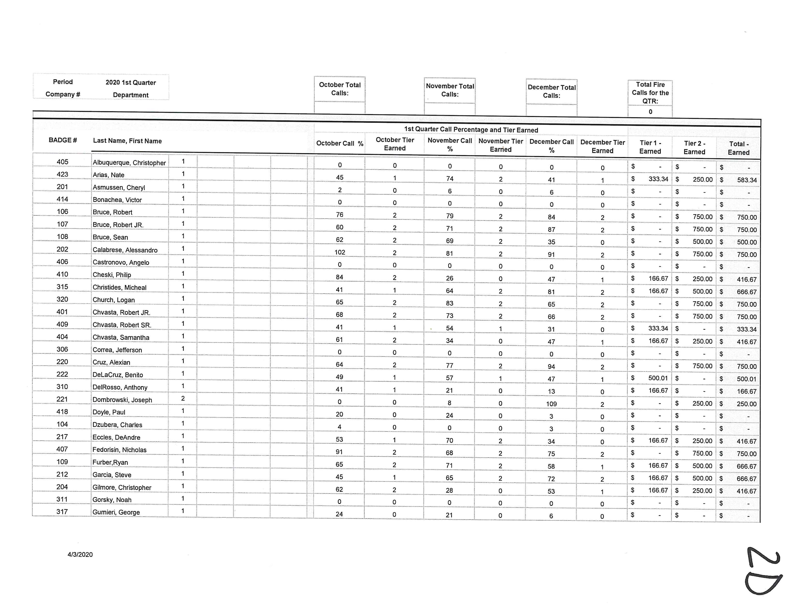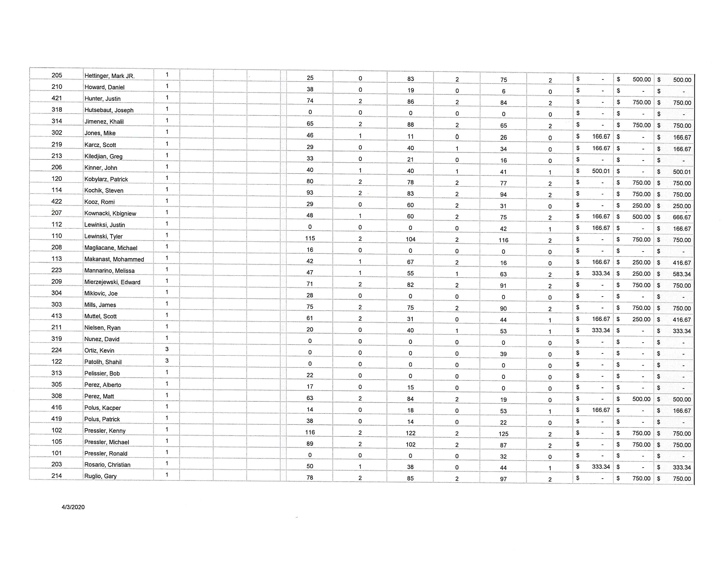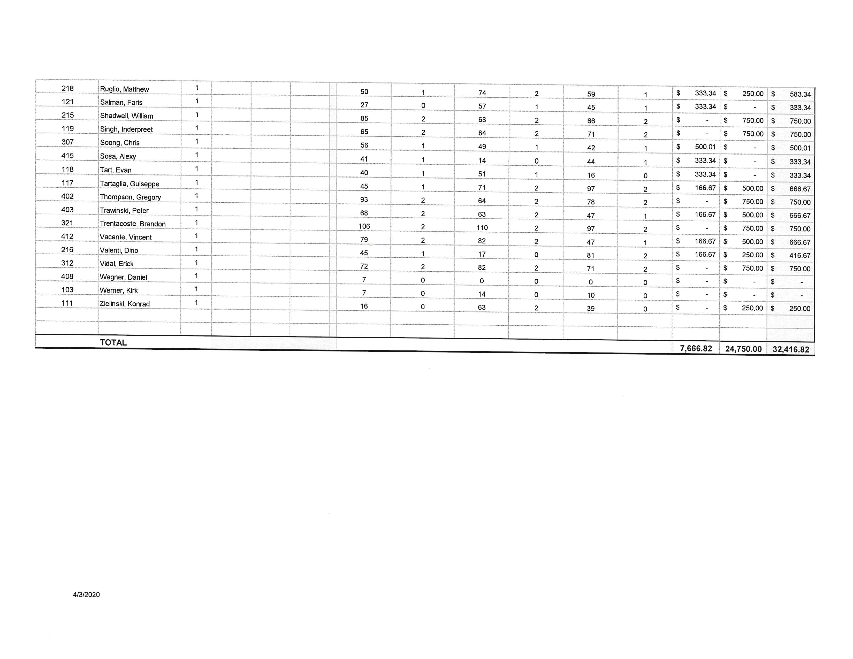

BOROUGH OF ELMWOOD PARK
BERGEN COUNTY, NEW JERSEY
RESOLUTION R-198-20
CONSENT AGENDA
RESOLUTION BY:
SECONDED BY:
RESOLUTION TO REFUND OVERPAYMENT

WHEREAS Tax Collector, Roy Riggitano, has advised Stanley Barylski, owner of Block 602 Lot 11, located at 40 Falmouth Avenue within the Borough of Elmwood Park, made an erroneous tax payment in excess of the amount due for the 2019 4th quarter in the amount of $3,352.86 and the 2020 1st quarter in the amount of $3,352.86; and

WHEREAS, the application of this payment resulted in an overpayment in an amount of $ 3,352.86 for the 4th quarter of 2019 and for the 1st quarter 2020, $3,352.86; and

WHEREAS, Stanley Barylski requests a refund of the over payment as the amount represents taxes beyond the amount due and therefore due a refund for the said amounts;

NOW, THEREFORE, BE IT RESOLVED by the Governing Authority of the Borough of Elmwood Park, County of Bergen, State of New Jersey that approval be granted to issue a check in the amount of $ 6,705.72, payable to Stanley Barylski and mailed to;

Stanley Barylski
336 River Drive
Garfield, New Jersey 07026

I, Roy Riggitano, Chief Financial Officer for the Borough of Elmwood Park do hereby confirm that there are sufficient funds available for this resolution.
________________________________ April 15, 2020
Roy Riggitano, Chief Financial Officer Dated

APPROVED: April 16, 2020
__________________________
Robert Colletti, Mayor
ATTEST: _____________________
Erin Delaney, MPA, RMC
Borough Clerk
Record of Council Vote on Passage
 | AYE | NAY | Abstain | Absent |  | AYE | NAY | Abstain | Absent
Fasolo |  |  |  |  | Pellegrine
Golabek |  |  |  |  | Wechtler
Ingui |  |  |  |  | Balistrieri
This resolution was approved by the Mayor and Council of the Borough of Elmwood Park at a regular scheduled meeting held on the 16th day of April 2020. Signed and sealed before me.
_____________________ _____________________
Erin Delaney, MPA, RMC Dated
Borough Clerk
BOROUGH OF ELMWOOD PARK
BERGEN COUNTY, NEW JERSEY
RESOLUTION R-199-20
CONSENT AGENDA
RESOLUTION BY:
SECONDED BY:
CORRECTIVE RESOLUTION TO PURCHASE RADIO EQUIPMENT
NORTHEAST COMMUNICATIONS – FIRE DEPARTMENT
WHEREAS, the Fire Department has requested to purchase radio equipment with funds set aside in a Bond Ordinance, specifically, Borough Ordinance 19-11 adopted on final hearing at the Regular Meeting of the Mayor and Council on June 20, 2019; and
WHEREAS, the equipment will be purchased through the Morris County Co-op contract #41 at a cost of $25,545.00 with Northeast Communications located in Wharton, New Jersey;
NOW THEREFORE BE IT RESOLVED, by the Mayor and Council of the Borough of Elmwood Park, County of Bergen, State of New Jersey that they hereby authorize the purchase of radio equipment totaling $25,545.00 with Northeast Communications.
BE IT FURTHER RESOLVED that Resolution R-159-20 be and is hereby rescinded.

I, Roy Riggitano, Chief Financial Officer for the Borough of Elmwood Park do hereby confirm that there are sufficient funds available for this resolution.
________________________________ April 15, 2020
Roy Riggitano, Chief Financial Officer Dated

APPROVED: April 16, 2020
__________________________
Robert Colletti, Mayor
ATTEST: _____________________
Erin Delaney, MPA, RMC
Borough Clerk
Record of Council Vote on Passage
 | AYE | NAY | Abstain | Absent |  | AYE | NAY | Abstain | Absent
Fasolo |  |  |  |  | Pellegrine
Golabek |  |  |  |  | Wechtler
Ingui |  |  |  |  | Balistrieri
This resolution was approved by the Mayor and Council of the Borough of Elmwood Park at a regular scheduled meeting held on the 16th day of April 2020. Signed and sealed before me.
_____________________ _____________________
Erin Delaney, MPA, RMC Dated
Borough Clerk

BOROUGH OF ELMWOOD PARK
BERGEN COUNTY, NEW JERSEY
RESOLUTION R-200-20
CONSENT AGENDA
RESOLUTION BY:
SECONDED BY:
AUTHORIZING THE SUBMISSION OF A TWA APPLICATION TO THE
STATE DEP – RIVER DRIVE DEVELOPMENT
WHEREAS, River Drive Development, LLC C/O BF Langan Consultants, LLC has prepared a TWA Application for submission to the State Department of Environmental Protection for their proposed mixed-use residential development located at 778 River Drive in Elmwood Park, NJ; and
WHEREAS, said application requires consent by the municipality in which the project is located to certify that the project as proposed conforms with the requirements of all municipal ordinances; and
WHEREAS, the application further requires that the municipality certify that to the best of its knowledge the wastewater conveyance system of the project has adequate capacity in accordance with state statutes; and
WHEREAS, the Governing Body and Borough Attorney Ingraffia have reviewed said application and find no issues with the same;
NOW, THEREFORE, BE IT RESOLVED, by the Mayor and Council of the Borough of Elmwood Park that Mayor Robert Colletti are hereby authorized to sign the TWA Application on behalf of the municipality.
APPROVED: April 16, 2020
__________________________
Robert Colletti, Mayor
ATTEST: _____________________
Erin Delaney, MPA, RMC
Borough Clerk
Record of Council Vote on Passage
 | AYE | NAY | Abstain | Absent |  | AYE | NAY | Abstain | Absent
Fasolo |  |  |  |  | Pellegrine
Golabek |  |  |  |  | Wechtler
Ingui |  |  |  |  | Balistrieri
This resolution was approved by the Mayor and Council of the Borough of Elmwood Park at a regular scheduled meeting held on the 16th day of April 2020. Signed and sealed before me.
_____________________ _____________________
Erin Delaney, MPA, RMC Dated
Borough Clerk

BOROUGH OF ELMWOOD PARK
BERGEN COUNTY, NEW JERSEY
RESOLUTION R-201-20
CONSENT AGENDA
RESOLUTION BY:
SECONDED BY:
APPOINTMENT TO BOARD OF HEALTH
BE IT RESOLVED, by the Mayor and Council of the Borough of Elmwood Park that the appointment of:
Jeanne Freitag
to the Board of Health for an unexpired term, term ending, December 31, 2022, and the same is hereby confirmed.

APPROVED: April 16, 2020
__________________________
Robert Colletti, Mayor
ATTEST: _____________________
Erin Delaney, MPA, RMC
Borough Clerk
Record of Council Vote on Passage
 | AYE | NAY | Abstain | Absent |  | AYE | NAY | Abstain | Absent
Fasolo |  |  |  |  | Pellegrine
Golabek |  |  |  |  | Wechtler
Ingui |  |  |  |  | Balistrieri
This resolution was approved by the Mayor and Council of the Borough of Elmwood Park at a regular scheduled meeting held on the 16th day of April 2020. Signed and sealed before me.
_____________________ _____________________
Erin Delaney, MPA, RMC Dated
Borough Clerk

BOROUGH OF ELMWOOD PARK
BERGEN COUNTY, NEW JERSEY
RESOLUTION R-202-20
CONSENT AGENDA
RESOLUTION BY:
SECONDED BY:

APPROVE HANDICAP PARKING SPACE
MARTHA AVENUE
WHEREAS, a request has been made to have a handicapped parking space located at 50 Martha Avenue; and
WHEREAS, the request and the area have been inspected by the Elmwood Park Police Department; and
WHEREAS, the Elmwood Park Police Department recommends approval of the space with the following specifications: sign to be placed directly in front of the residence;
NOW THEREFORE BE IT RESOLVED, by the Mayor and Council of the Borough of Elmwood Park that the following handicapped parking space be approved.

APPROVED: April 16, 2020
__________________________
Robert Colletti, Mayor
ATTEST: _____________________
Erin Delaney, MPA, RMC
Borough Clerk

Record of Council Vote on Passage
 | AYE | NAY | Abstain | Absent |  | AYE | NAY | Abstain | Absent
Fasolo |  |  |  |  | Pellegrine
Golabek |  |  |  |  | Wechtler
Ingui |  |  |  |  | Balistrieri
This resolution was approved by the Mayor and Council of the Borough of Elmwood Park at a regular scheduled meeting held on the 16th day of April 2020. Signed and sealed before me.
_____________________ _____________________
Erin Delaney, MPA, RMC Dated
Borough Clerk

BOROUGH OF ELMWOOD PARK
BERGEN COUNTY, NEW JERSEY
RESOLUTION R-203-20
CONSENT AGENDA
RESOLUTION BY:
SECONDED BY:
RESCIND RESOLUTION R-155-20
RESOLUTION TO REFUND OVERPAYMENT
BE IT RESOLVED, by the Mayor and Council of the Borough of Elmwood Park that Resolution R-155-20 be and is hereby rescinded due to an internal error in the Tax Department.

APPROVED: April 16, 2020
__________________________
Robert Colletti, Mayor
ATTEST: _____________________
Erin Delaney, MPA, RMC
Borough Clerk

Record of Council Vote on Passage
 | AYE | NAY | Abstain | Absent |  | AYE | NAY | Abstain | Absent
Fasolo |  |  |  |  | Pellegrine
Golabek |  |  |  |  | Wechtler
Ingui |  |  |  |  | Balistrieri
This resolution was approved by the Mayor and Council of the Borough of Elmwood Park at a regular scheduled meeting held on the 16th day of April 2020. Signed and sealed before me.
_____________________ _____________________
Erin Delaney, MPA, RMC Dated
Borough Clerk

BOROUGH OF ELMWOOD PARK
BERGEN COUNTY, NEW JERSEY
RESOLUTION R-204-20
CONSENT AGENDA
RESOLUTION BY:
SECONDED BY:
RESOLUTION TO APPROVE THE CONSENT AGENDA
BE IT RESOLVED, by the Mayor and Council of the Borough of Elmwood Park that the actions noted in the Consent Agenda, Resolutions R-178-20 through R-204-20 be and are hereby approved and the proper officers are directed to take necessary action on same.

APPROVED: April 16, 2020
__________________________
Robert Colletti, Mayor
ATTEST: _____________________
Erin Delaney, MPA, RMC
Borough Clerk

Record of Council Vote on Passage
 | AYE | NAY | Abstain | Absent |  | AYE | NAY | Abstain | Absent
Fasolo |  |  |  |  | Pellegrine
Golabek |  |  |  |  | Wechtler
Ingui |  |  |  |  | Balistrieri
This resolution was approved by the Mayor and Council of the Borough of Elmwood Park at a regular scheduled meeting held on the 16th day of April 2020. Signed and sealed before me.
_____________________ _____________________
Erin Delaney, MPA, RMC Dated
Borough Clerk

